**PYTHON PROJECT**

**Python Functions**

A collection of related assertions that carry out a mathematical, analytical, or evaluative operation is known as a function. An assortment of proclamations called Python Capabilities returns the specific errand. Python functions are necessary for intermediate-level programming and are easy to define. Function names meet the same standards as variable names do. The objective is to define a function and group-specific frequently performed actions. Instead of repeatedly creating the same code block for various input variables, we can call the function and reuse the code it contains with different variables.

**Illustration of a User-Defined Function**

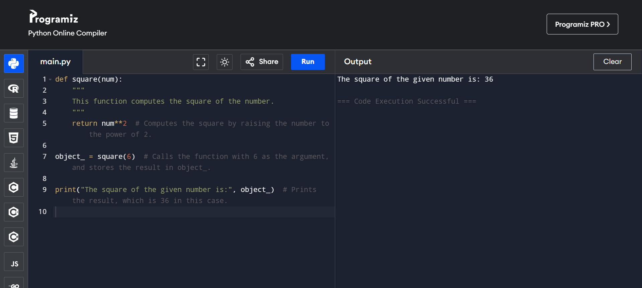

**Calling a Function**

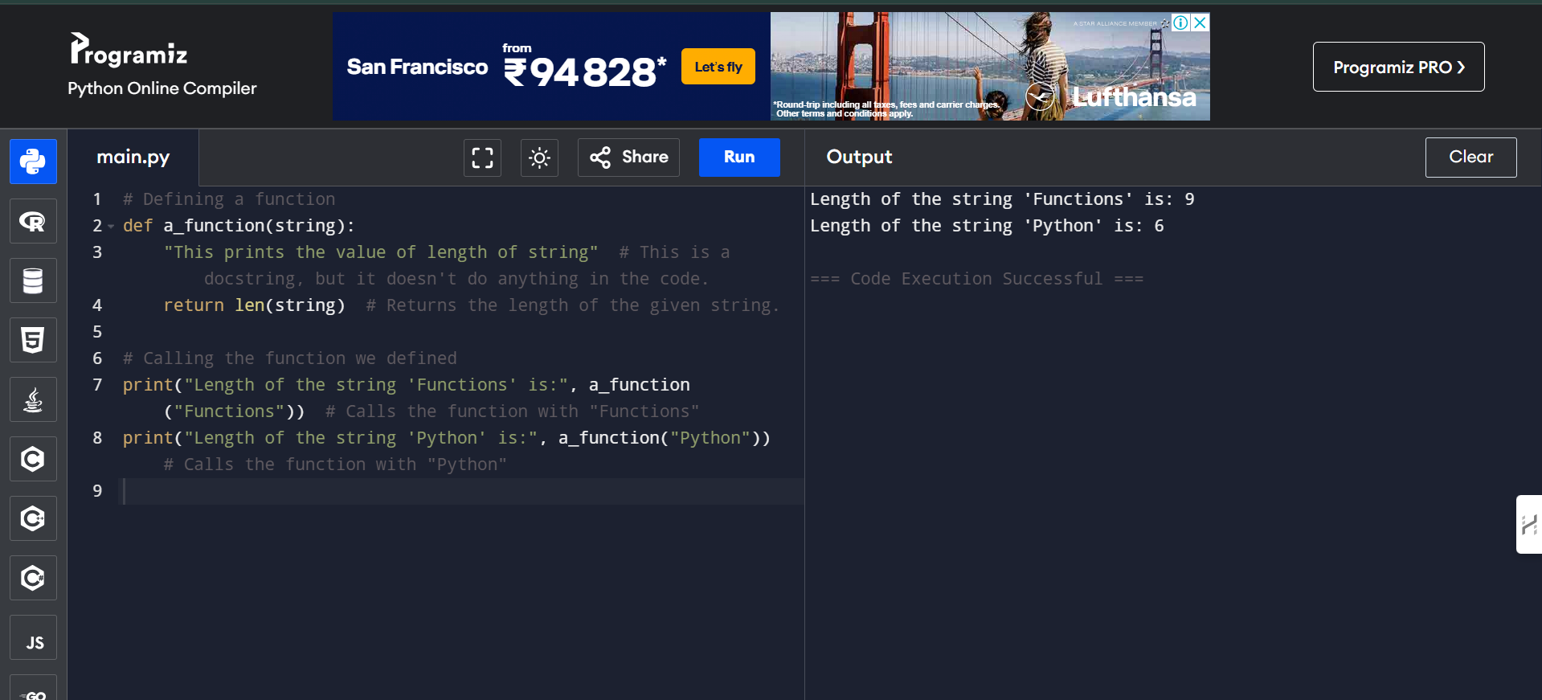

**Pass by Reference vs. Pass by Value**

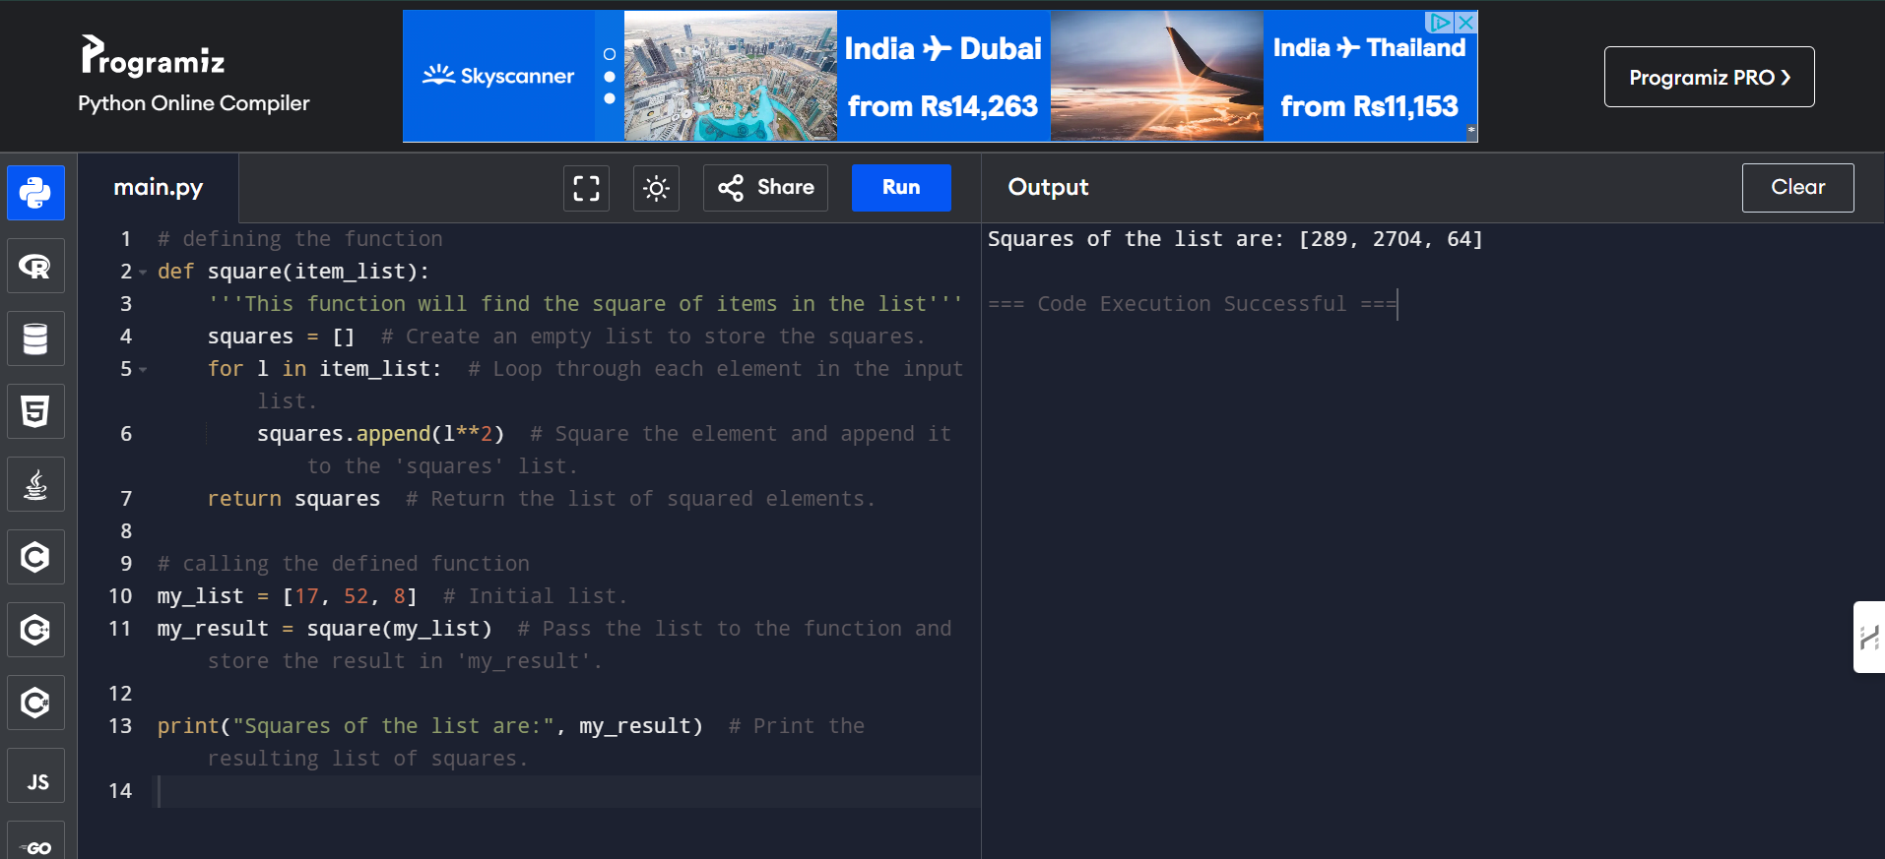

**Function Arguments**

1. **Default Arguments**

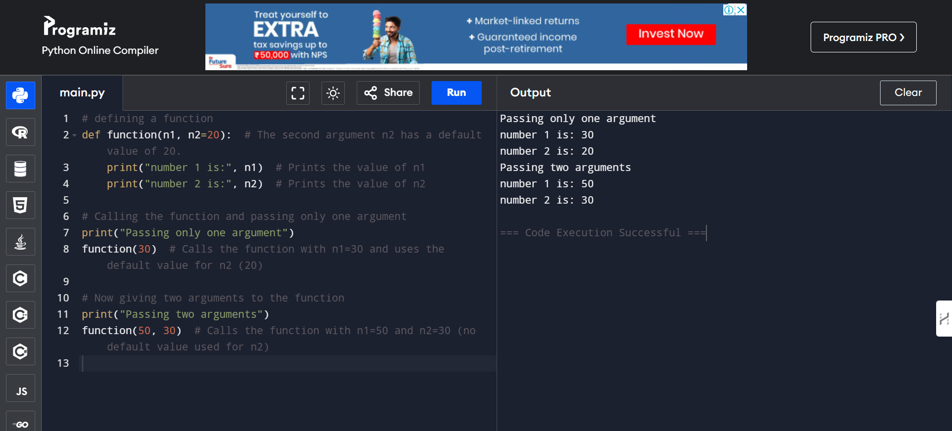

1. **Keyword Arguments**

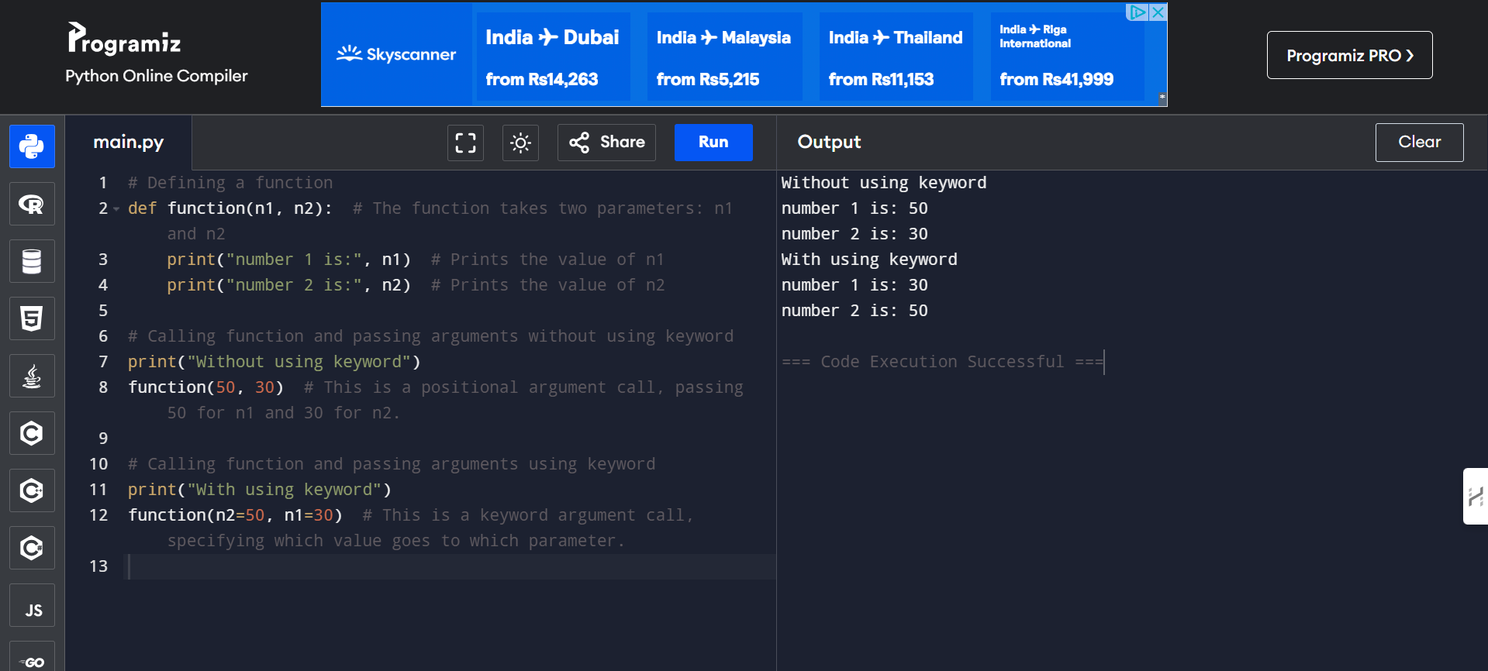

1. **Required Arguments**

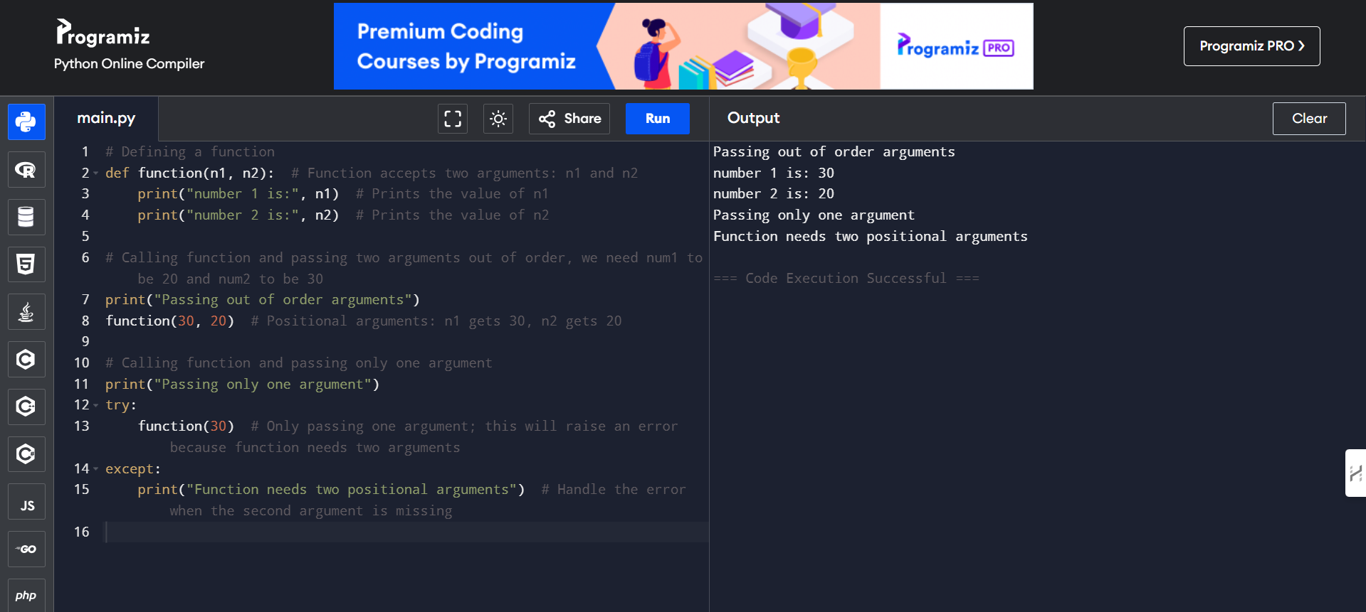

1. **Variable-Length Arguments**

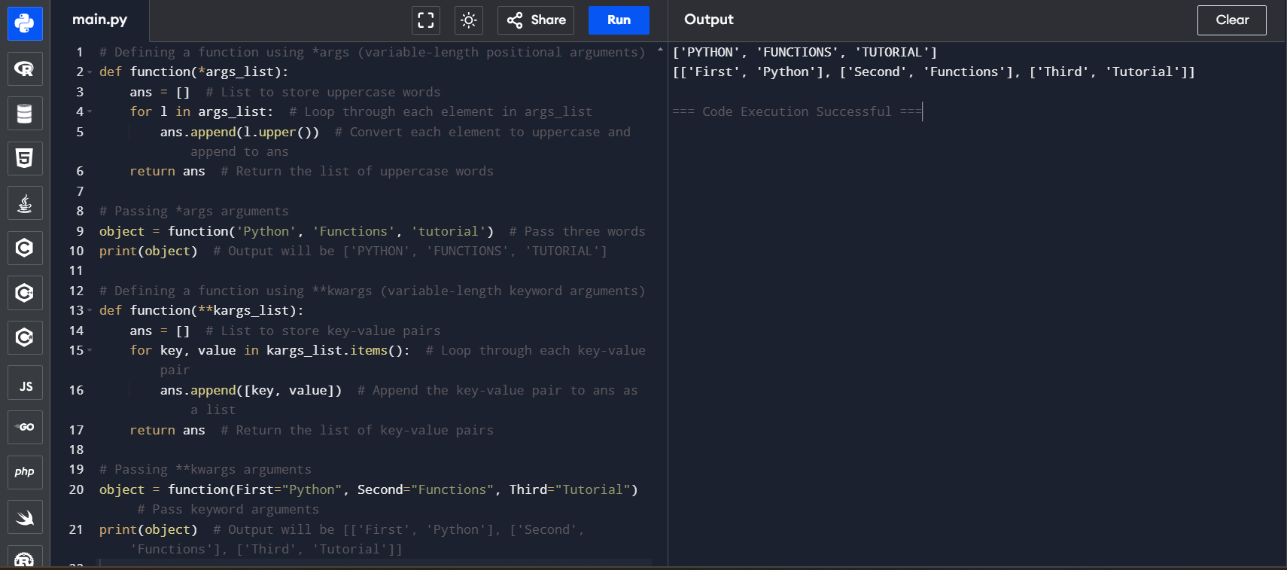

**return Statement**

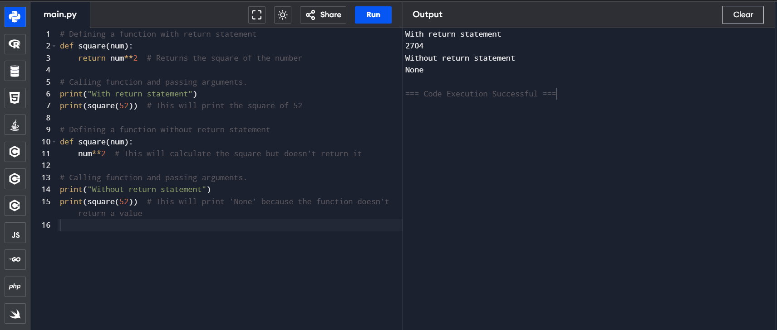

**The Anonymous Functions**

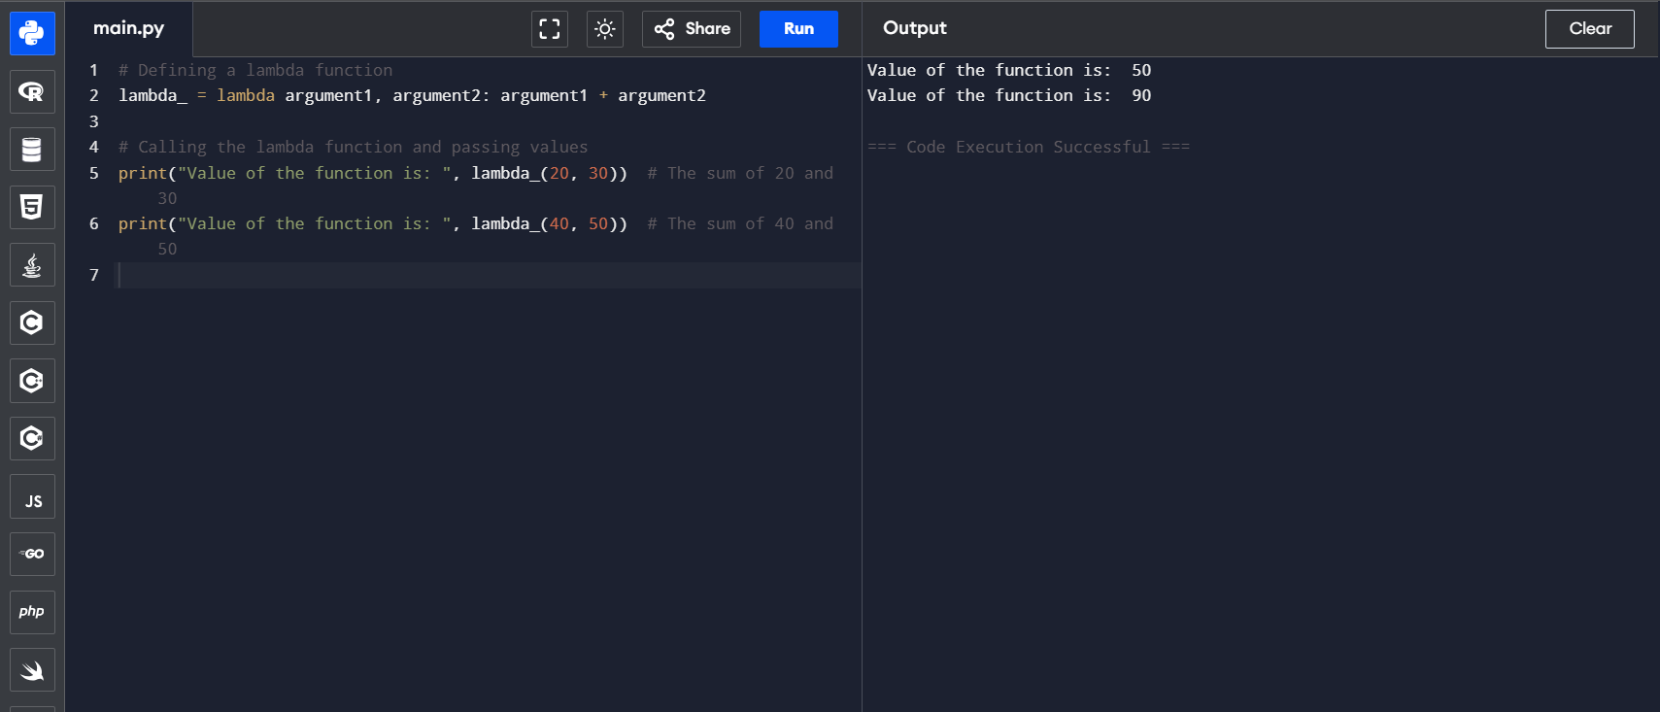

**Scope and Lifetime of Variables**

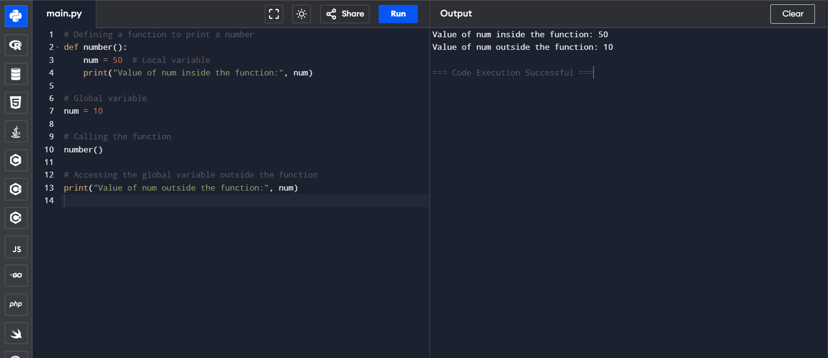

**Python Capability inside Another Capability**

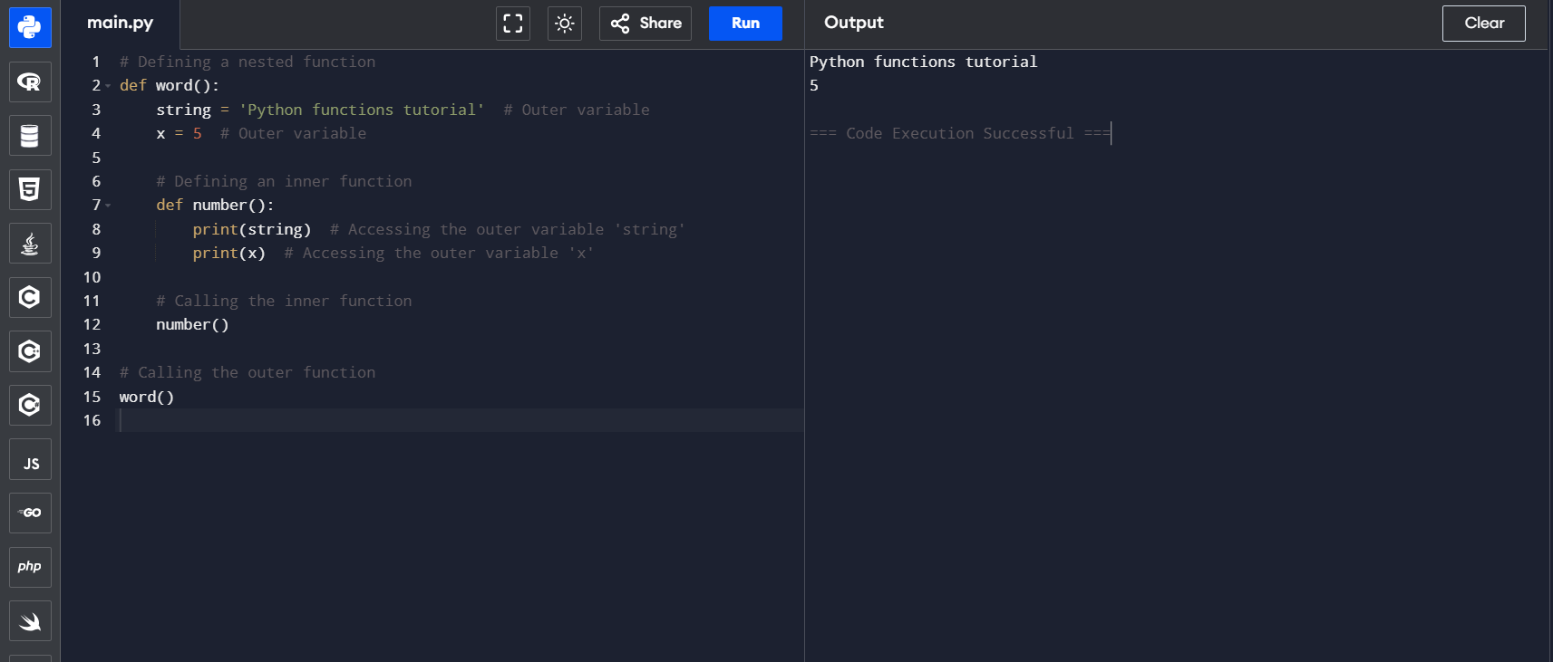

**Python Built-in Functions**

**Python abs() Function Example**

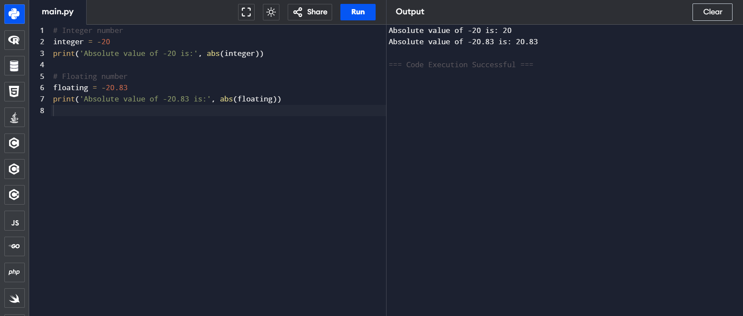

**Python all() Function**

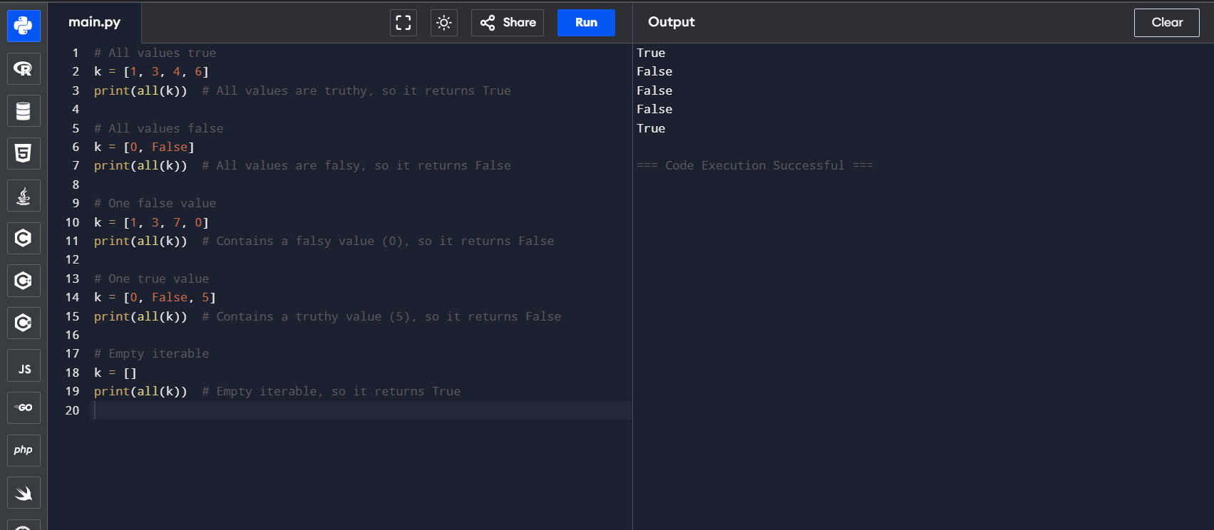

**Python bin() Function**

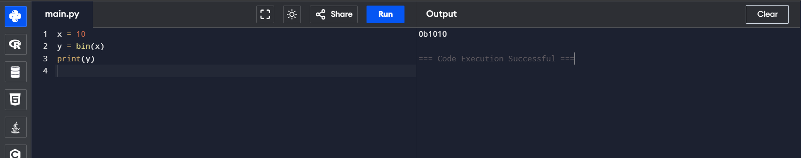

**Python bool()**

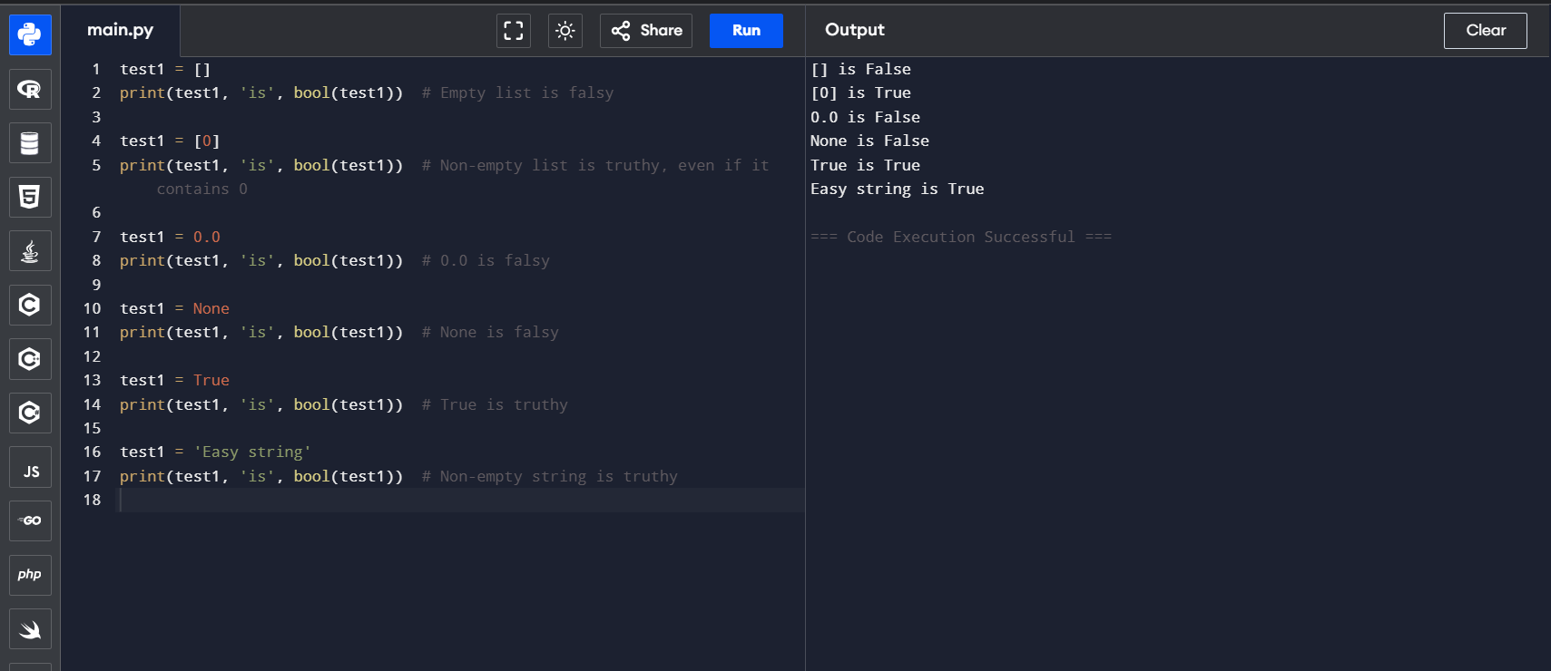

**Python bytes()**

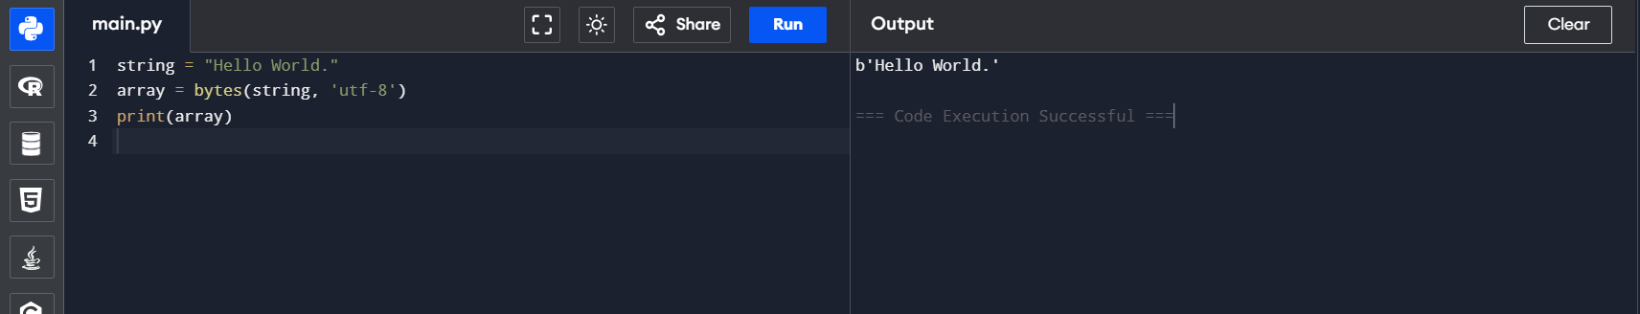

**Python callable() Function**

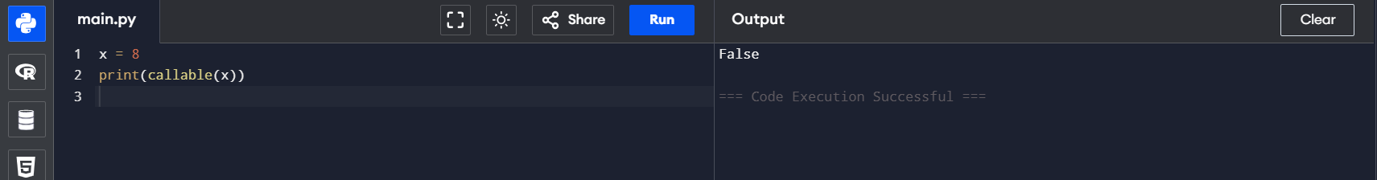

**Python compile() Function**

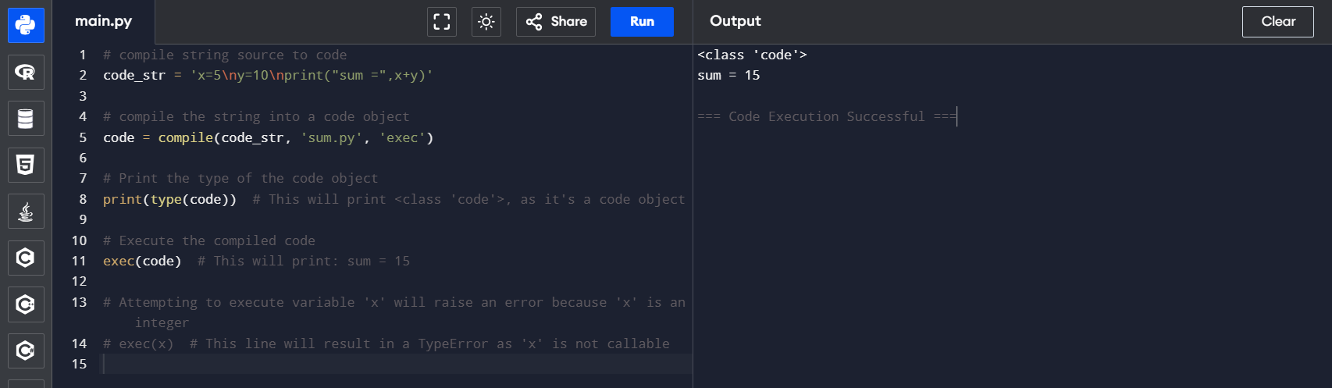

**Python exec() Function**

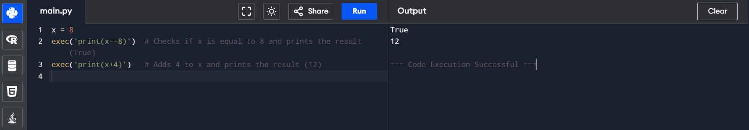

**Python sum() Function**

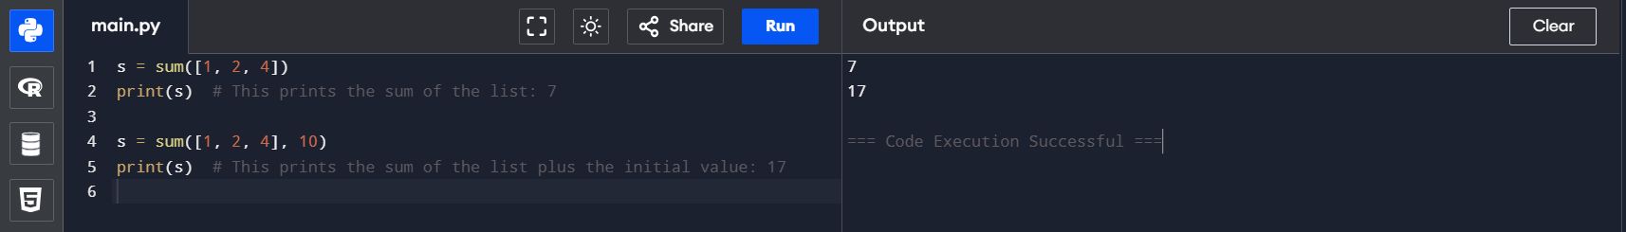

**Python any() Function**

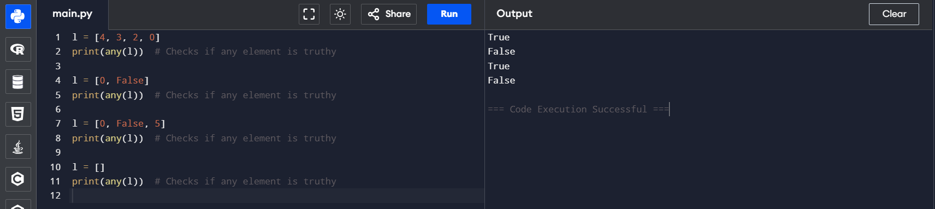

**Python ascii() Function**

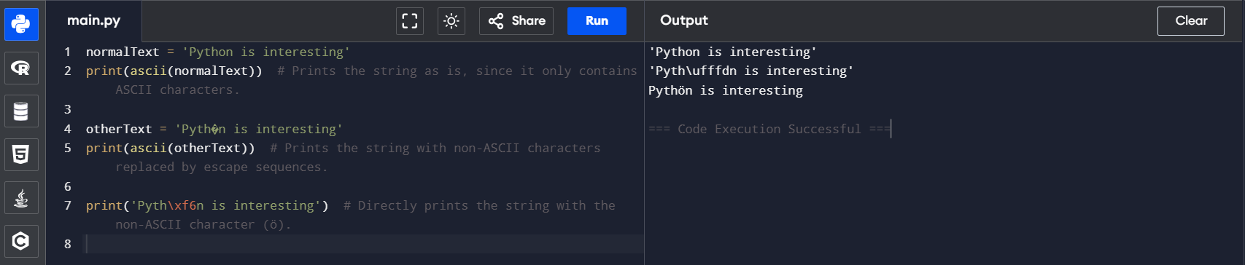

**Python bytearray()**

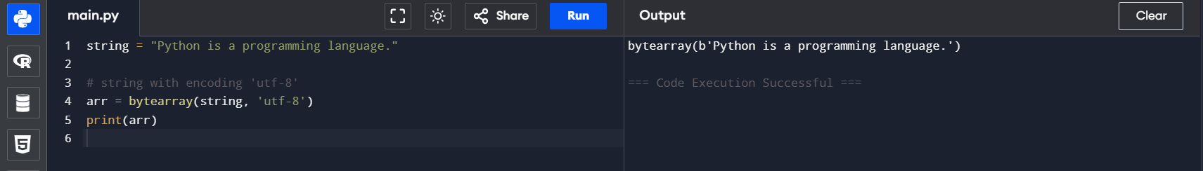

**Python eval() Function**

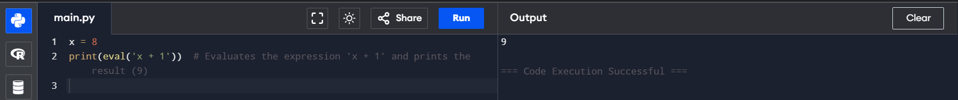

**Python float()**

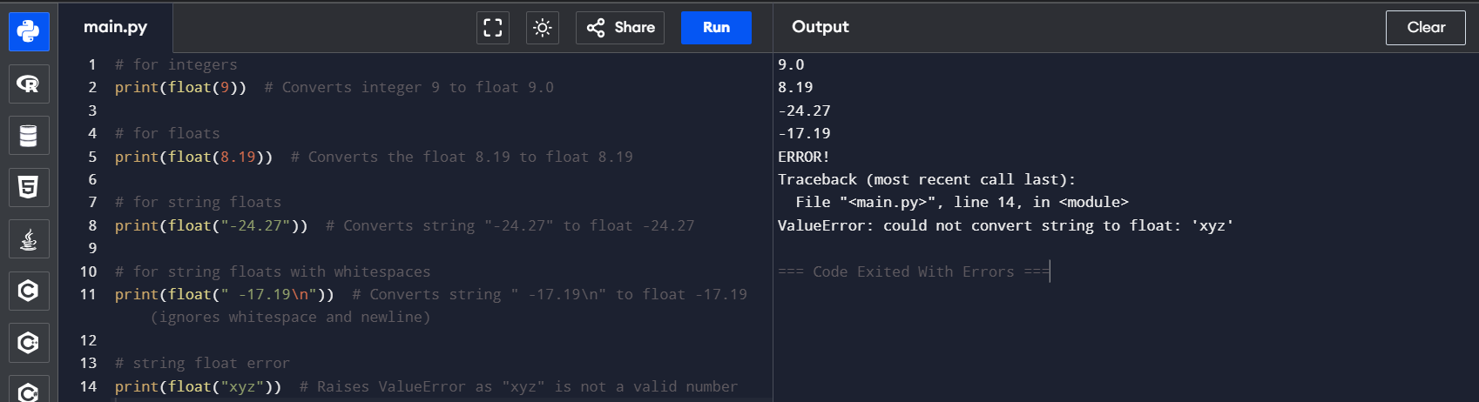

**Python format() Function**

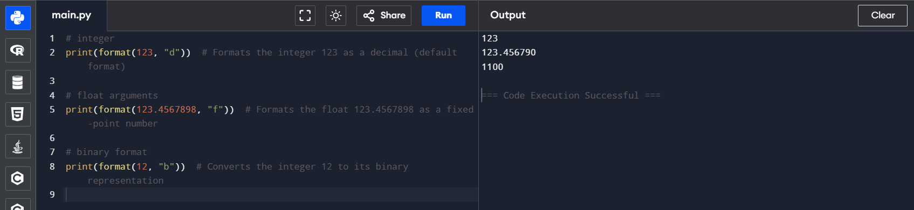

**Python frozenset()**

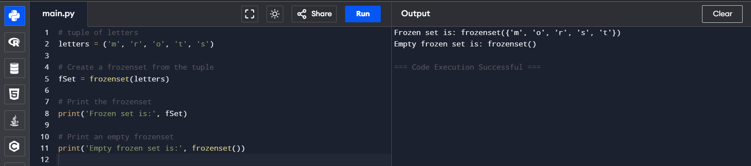

**Python getattr() Function**

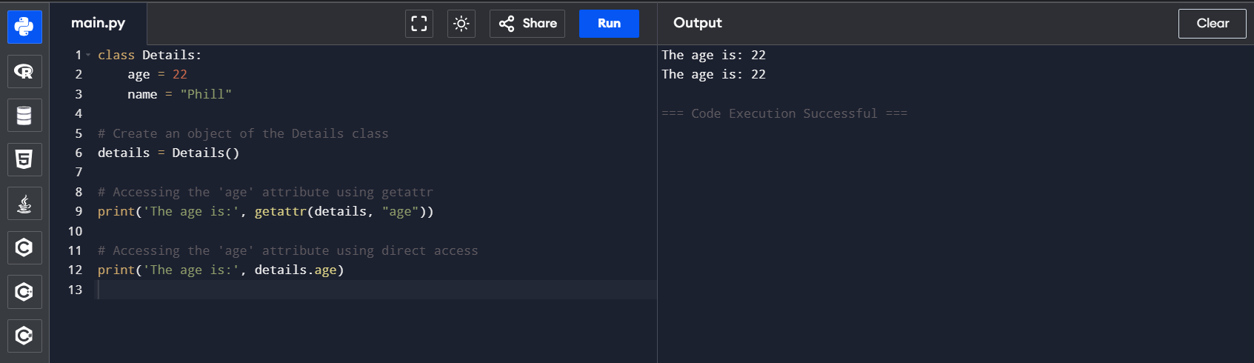

**Python globals() Function**

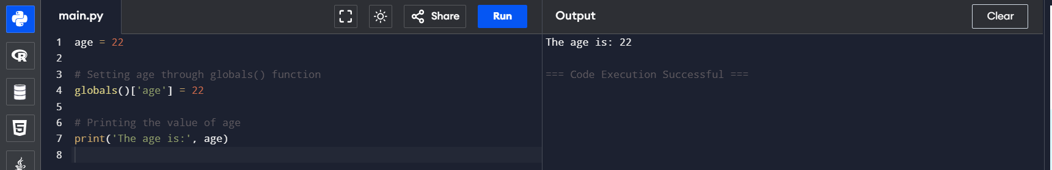

**Python hasattr() Function**

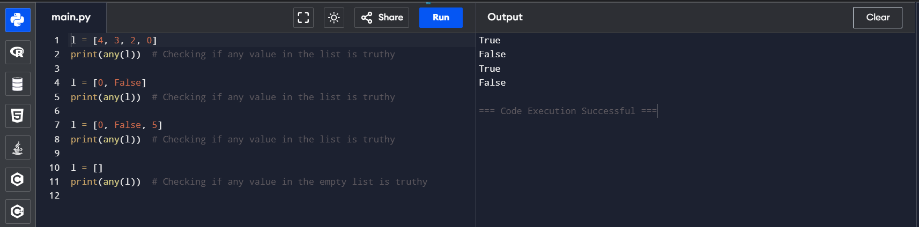

**Python iter() Function**

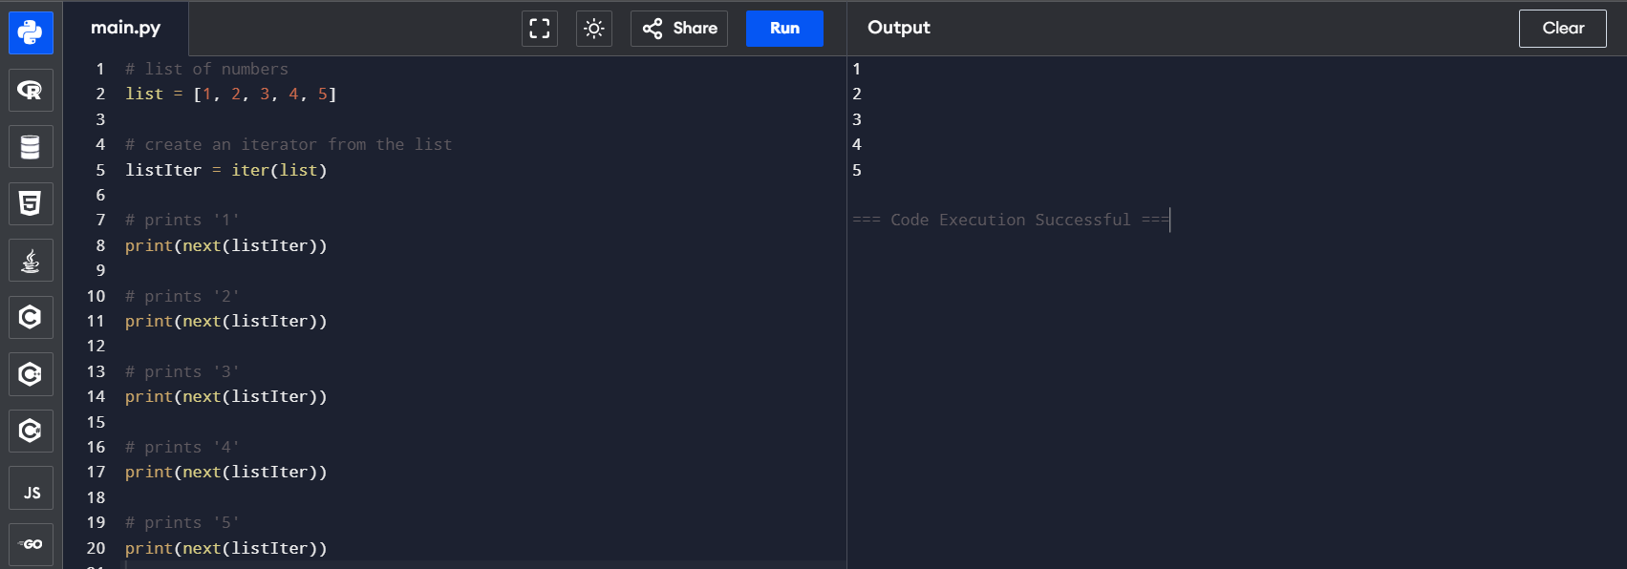

**Python list()**

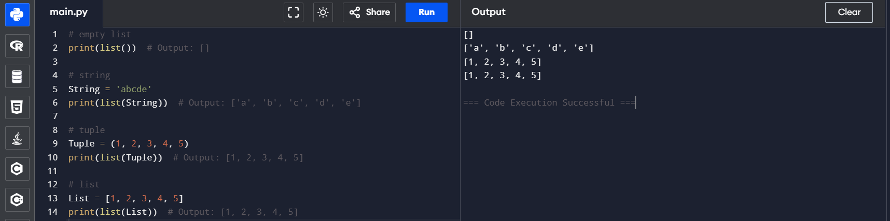

**Python locals() Function**

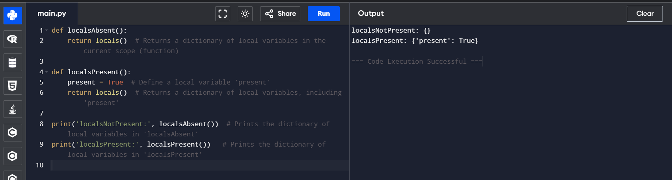

**Python map() Function**

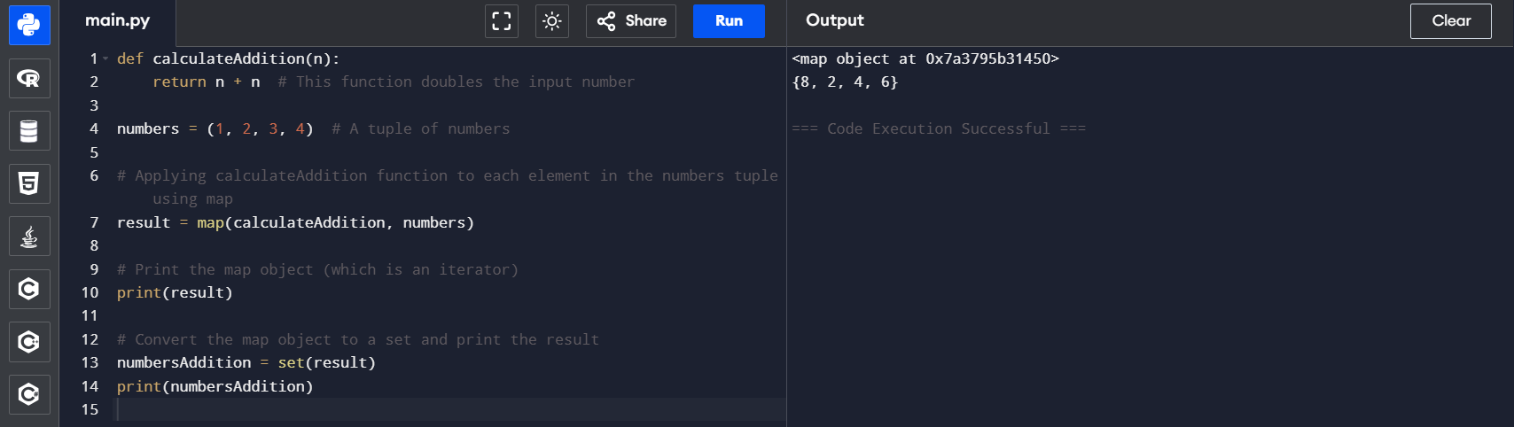

**Python memoryview() Function**

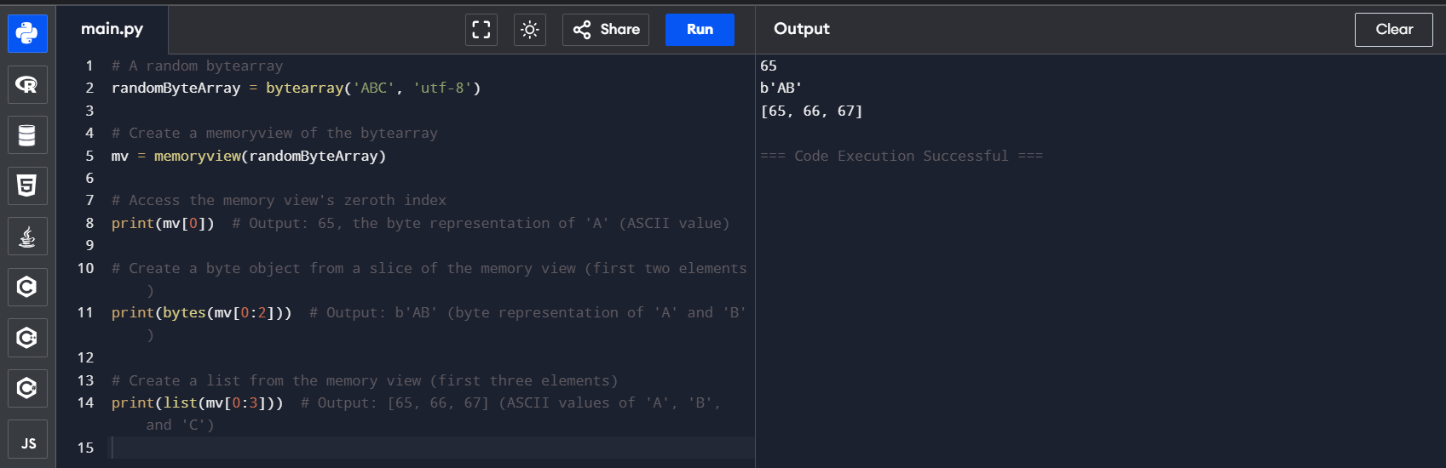

**Python object()**

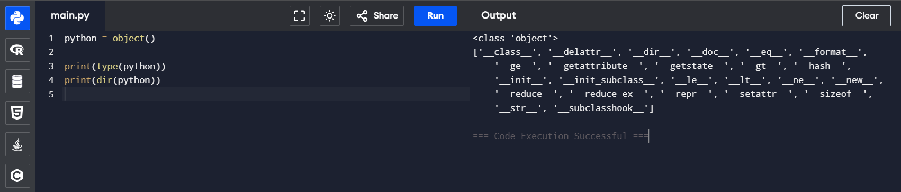

**Python chr() Function**

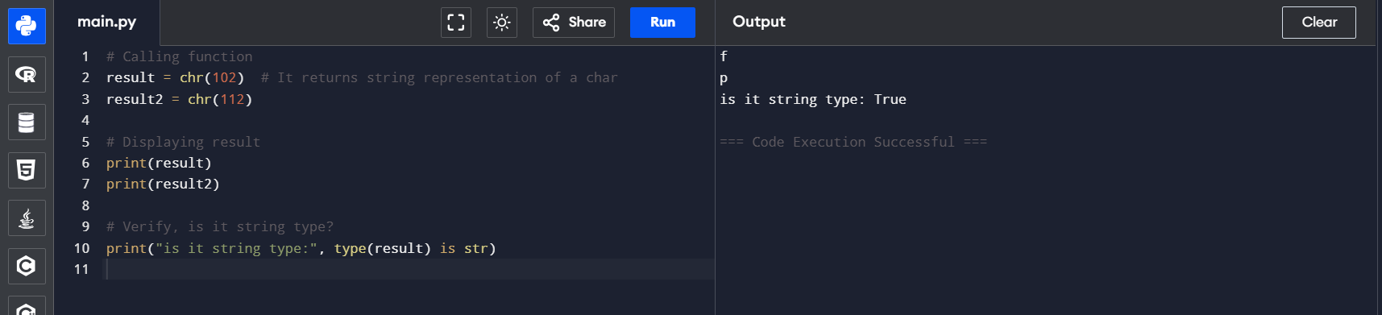

**Python complex()**

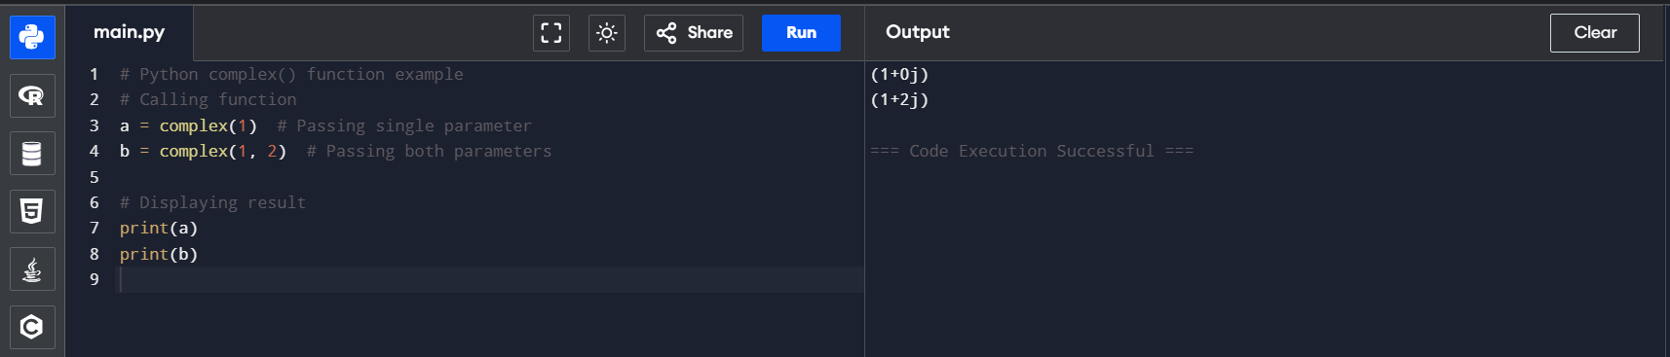

**Python delattr() Function**

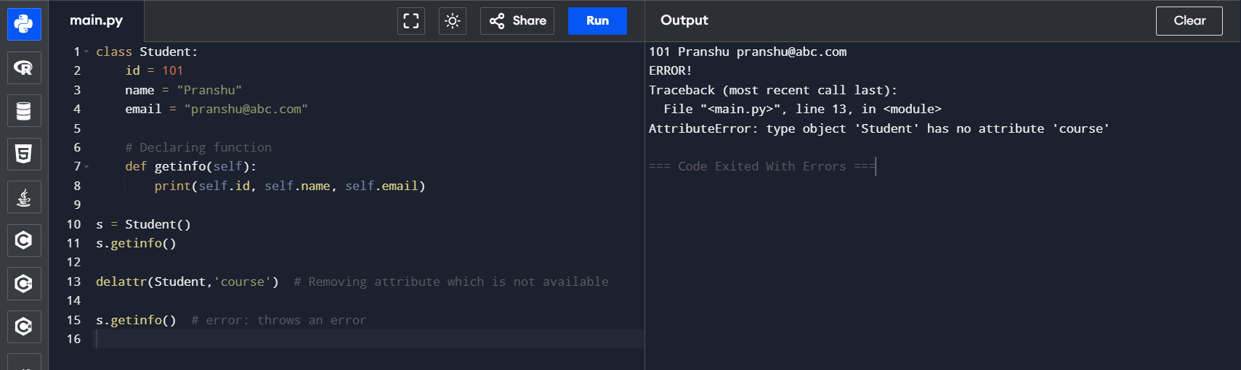

**Python dir() Function**

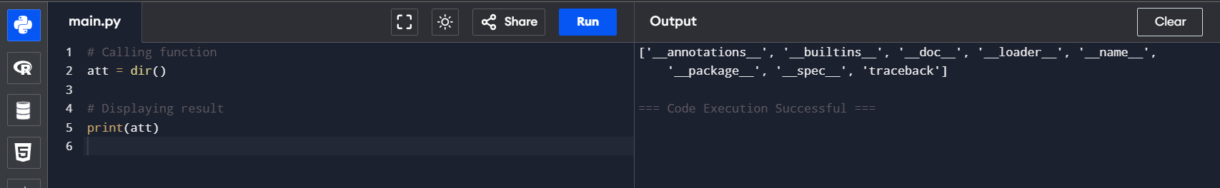

**Python divmod() Function**

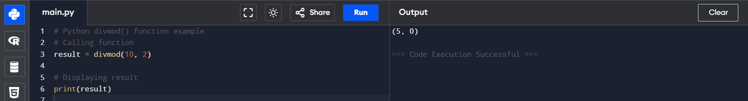

**Python enumerate() Function**

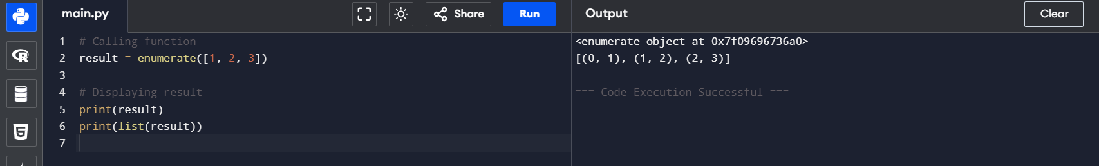

**Python dict()**

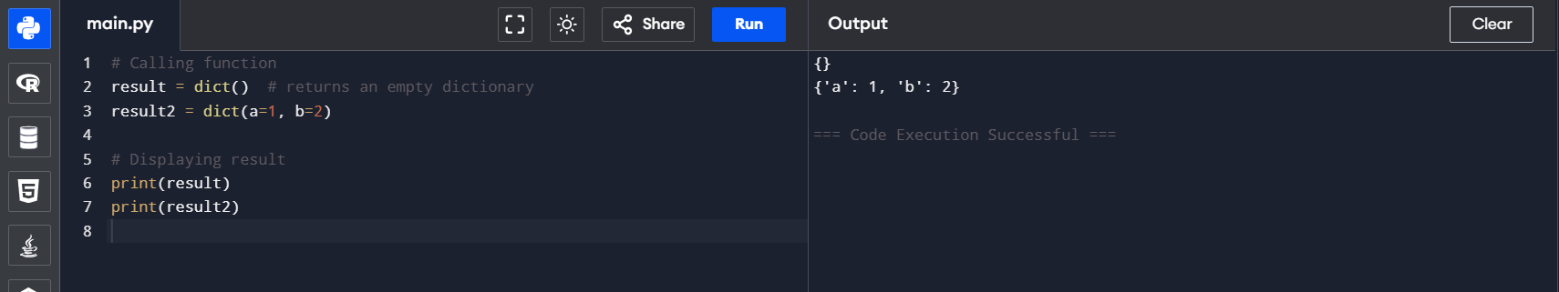

**Python filter() Function**

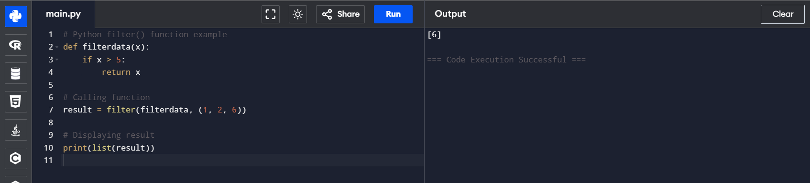

**Python hash() Function**

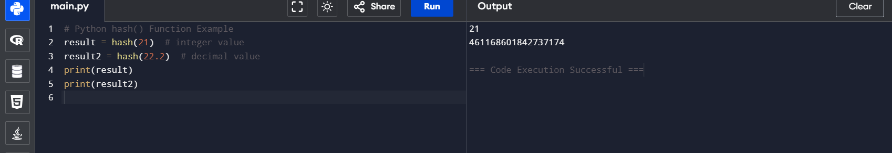

**Python help() Function**

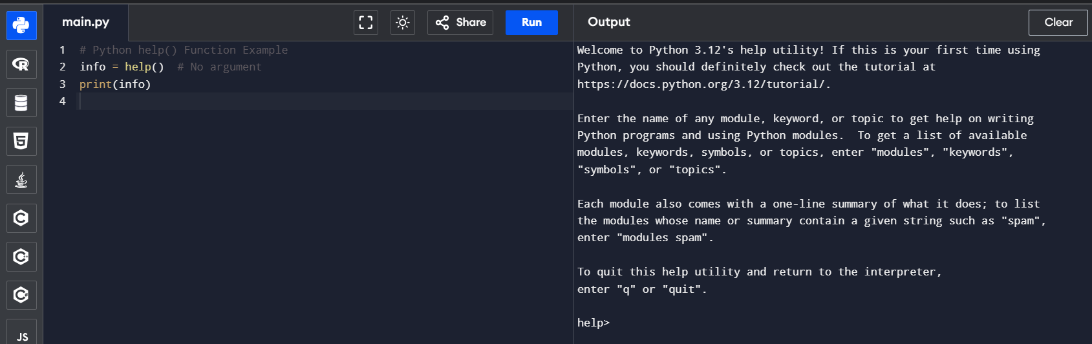

**Python min() Function**

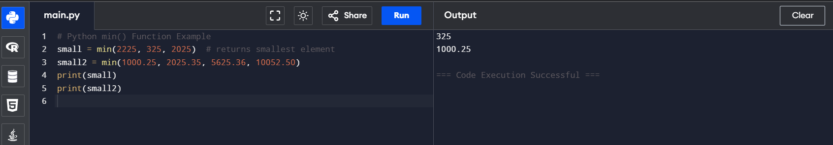

**Python set() Function**

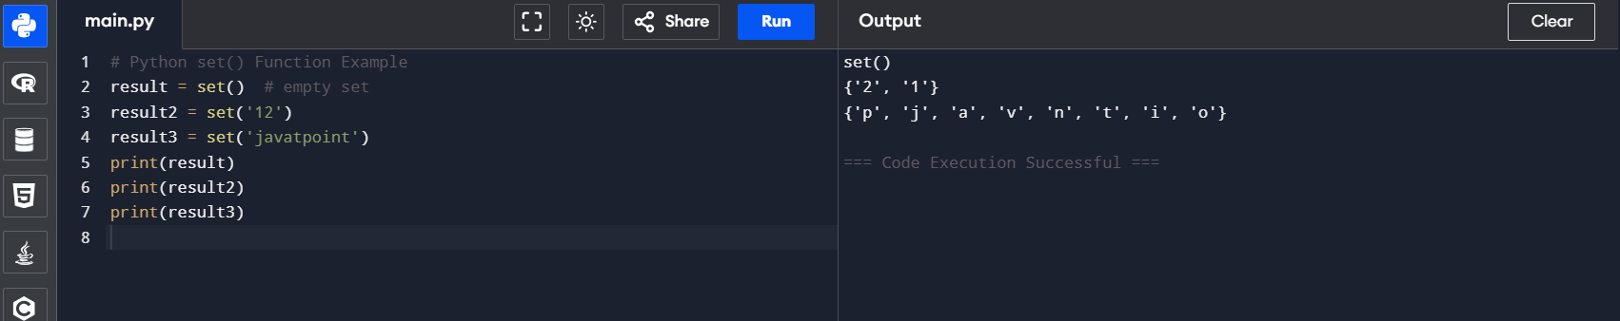

**Python hex() Function**

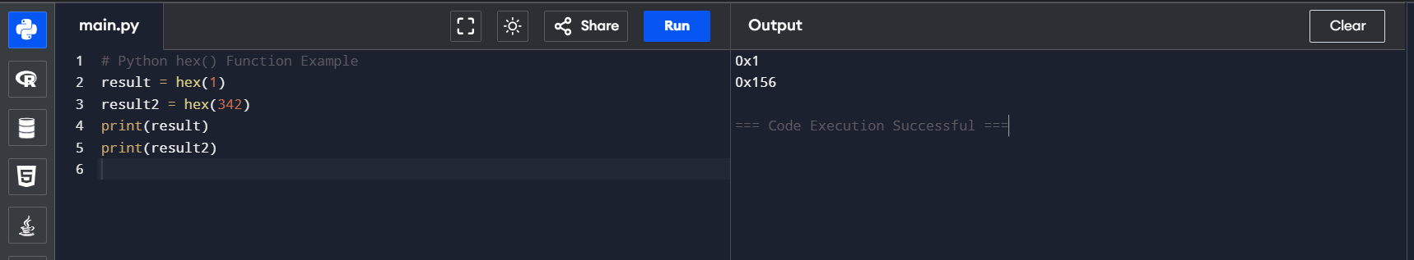

**Python id() Function**

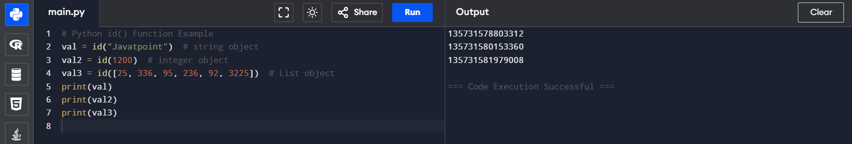

**Python setattr() Function**

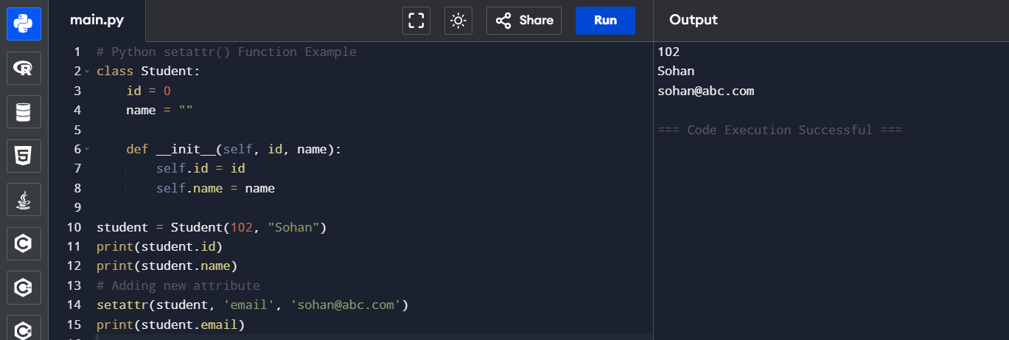

**Python slice() Function**

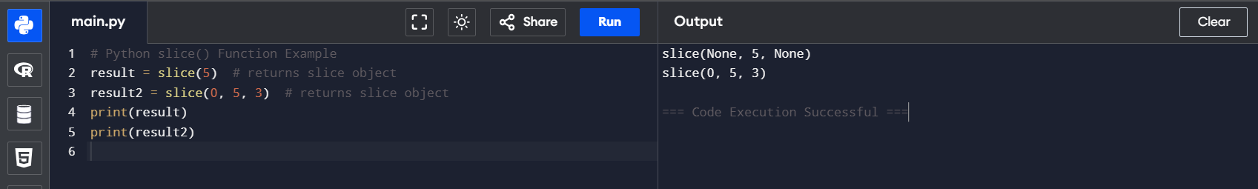

**Python sorted() Function**

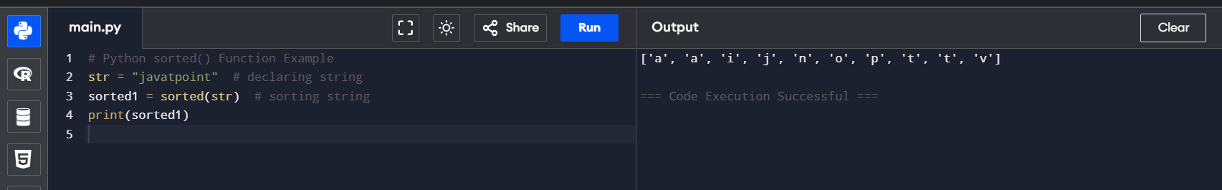

**Python next() Function**

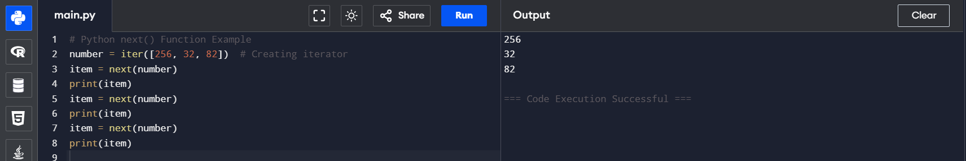

**Python input() Function**

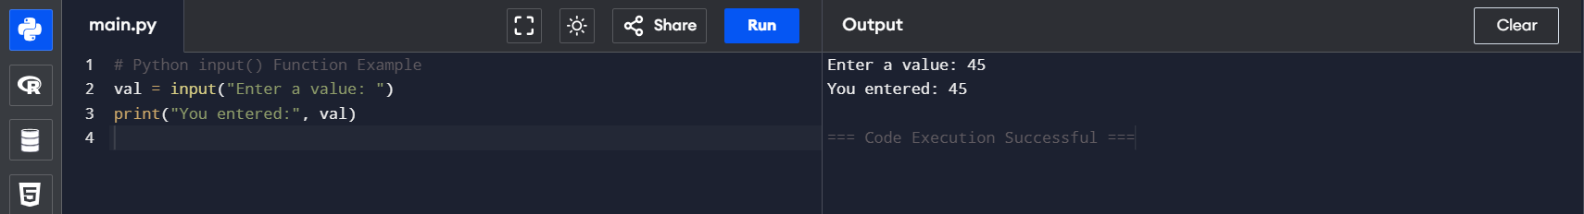

**Python int() Function**

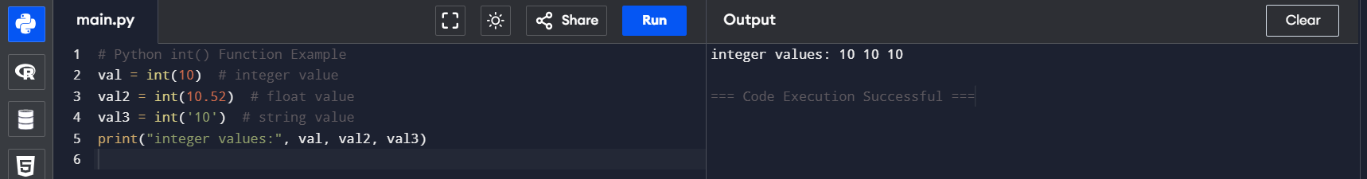

**Python isinstance() Function**

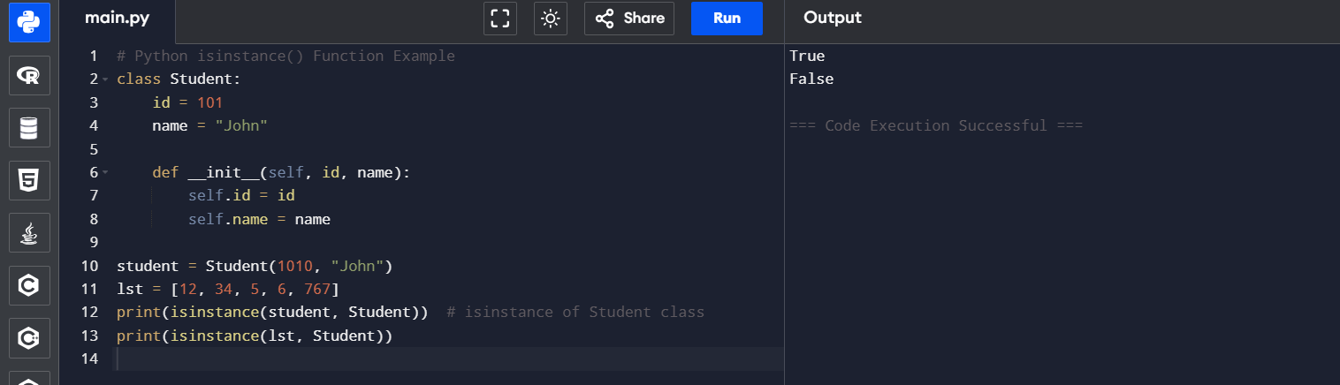

**Python oct() Function**



**Python ord() Function**

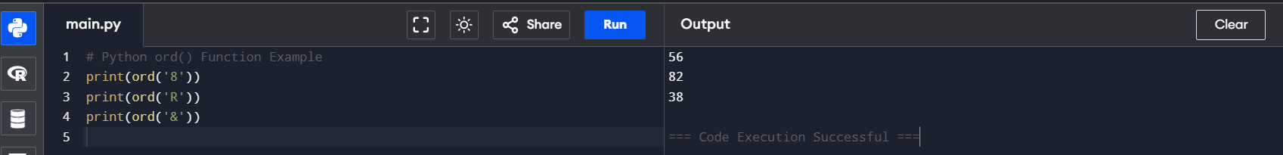

**Python pow() Function**

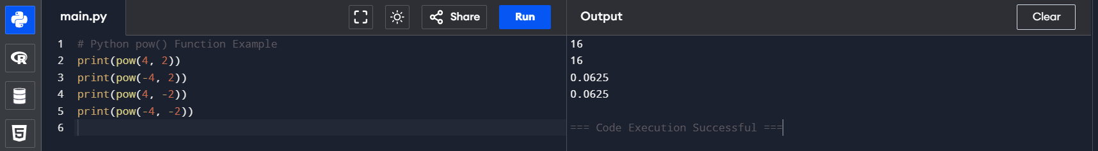

**Python print() Function**

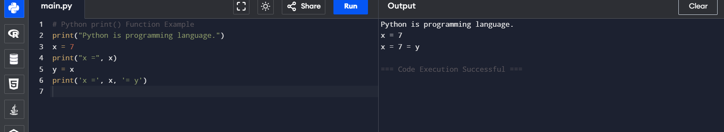

**Python range() Function**

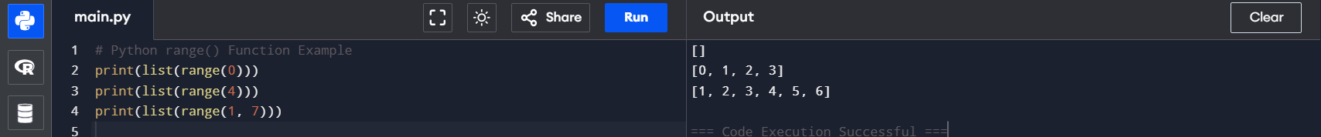

**Python reversed() Function**

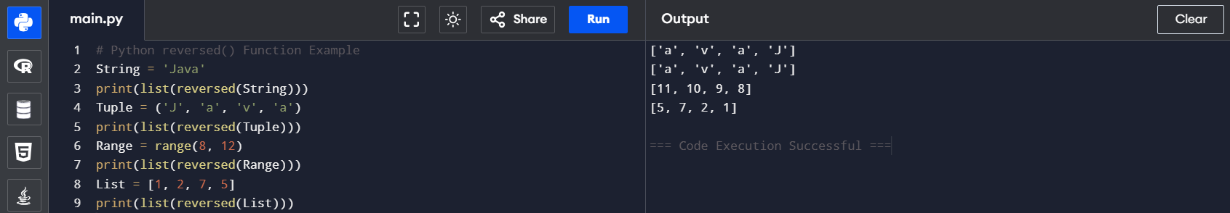

**Python round() Function**

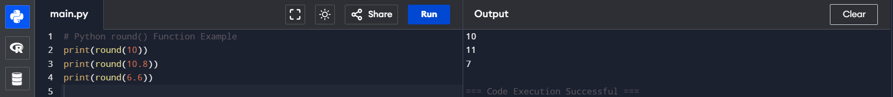

**Python issubclass() Function**

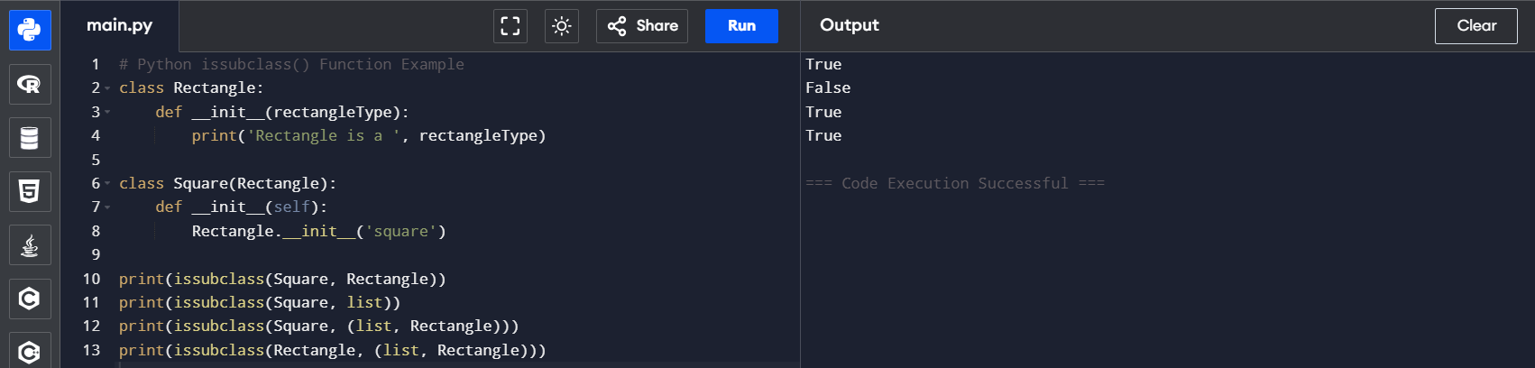

**Python str**



**Python tuple() Function**

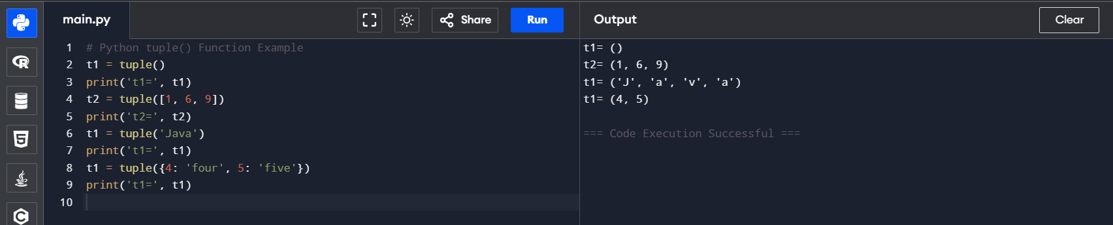

**Python type()**

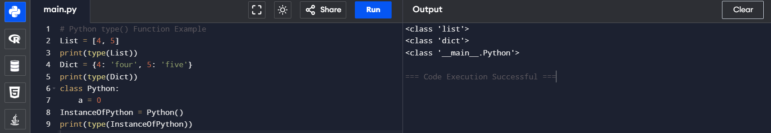

**Python vars() function**

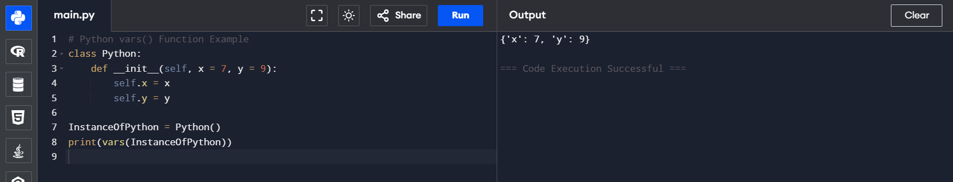

**Python zip() Function**

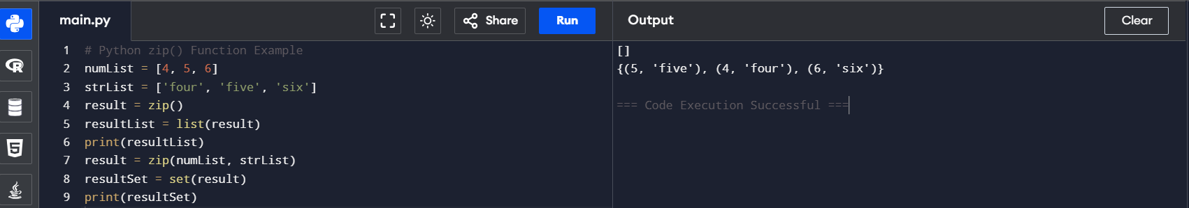

**Python Lambda Functions**

**Code 1:**

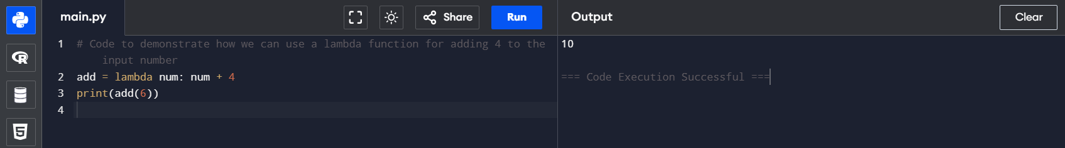

**Program Code 2:**

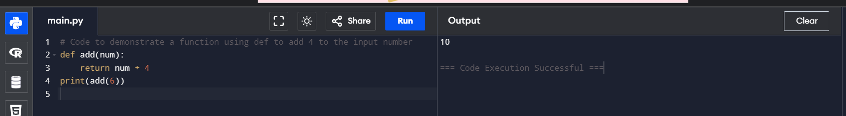

**Program Code 3:**

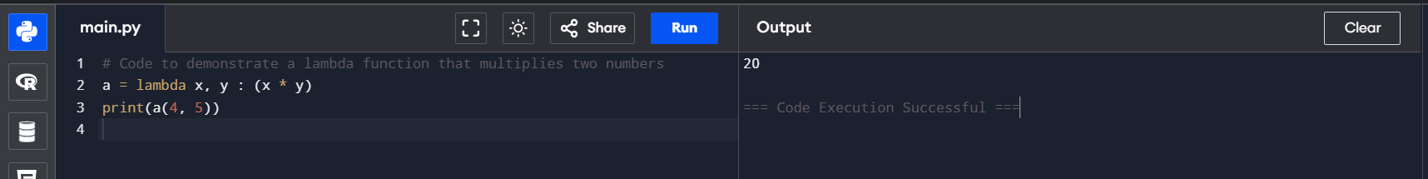

**Program Code 4:**

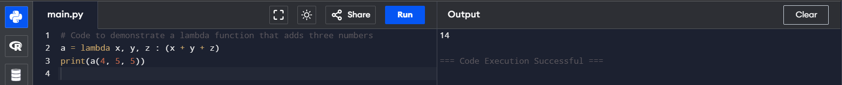

**What's the Distinction Between Lambda and Def Functions?**

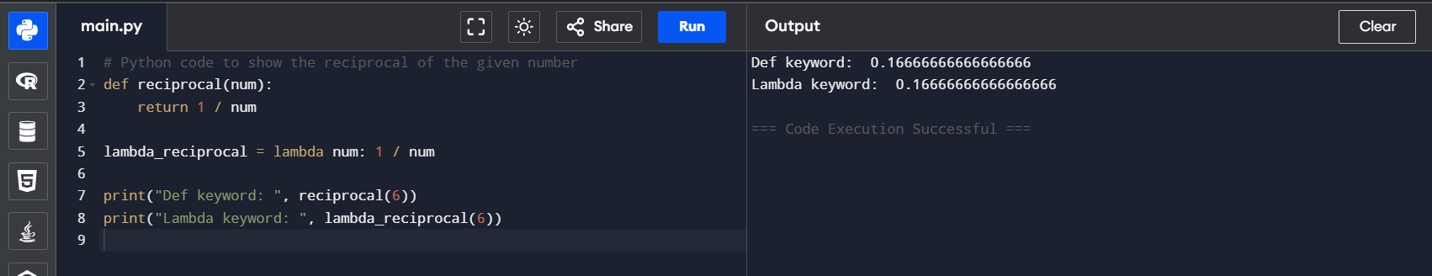

**Using Lambda Function with filter()**

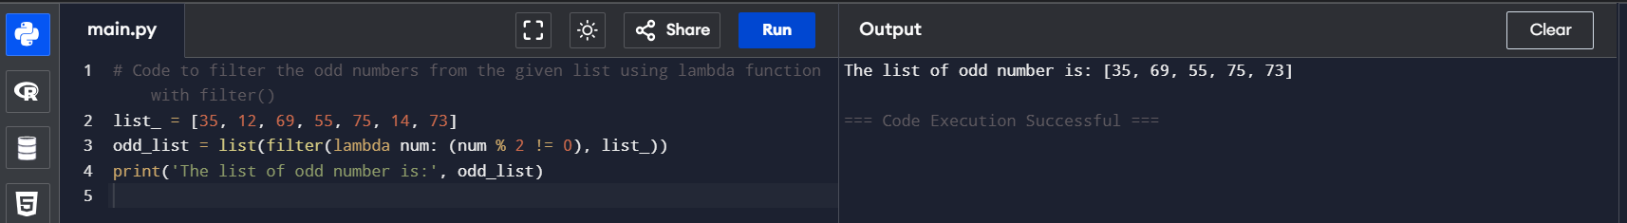

**Using Lambda Function with map()**

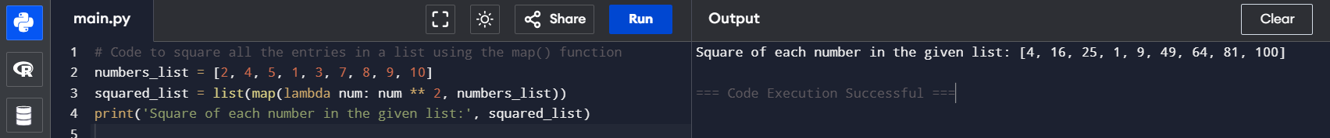

**Using Lambda Function with List Comprehension**

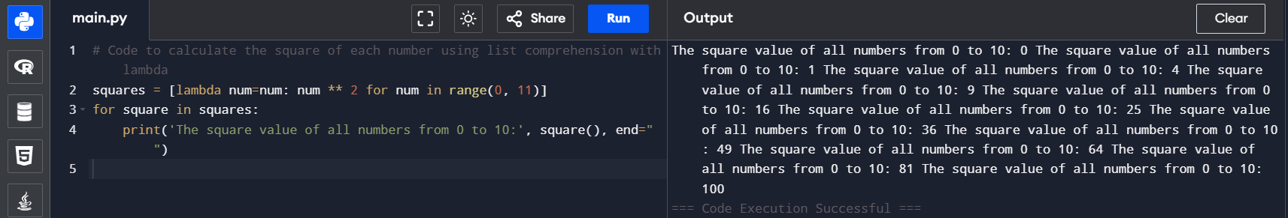

**Using Lambda Function with if-else**

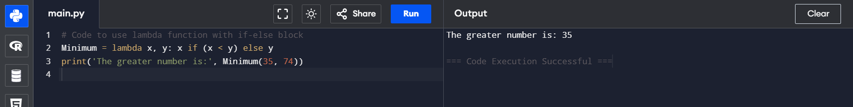

**Using Lambda with Multiple Statements**

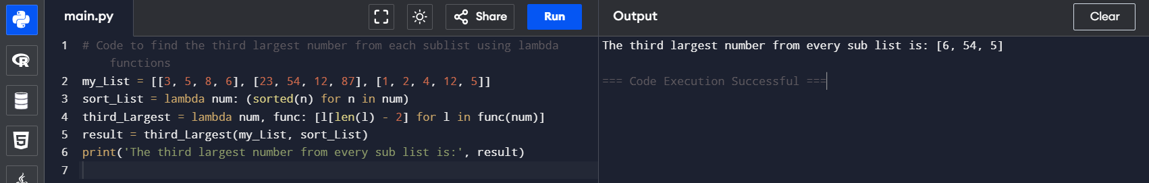

**Python Modules**

Modular programming is the practice of segmenting a single, complicated coding task into multiple, simpler, easier-to-manage sub-tasks. We call these subtasks modules. Therefore, we can build a bigger program by assembling different modules that act like building blocks.

**Python import Statement**

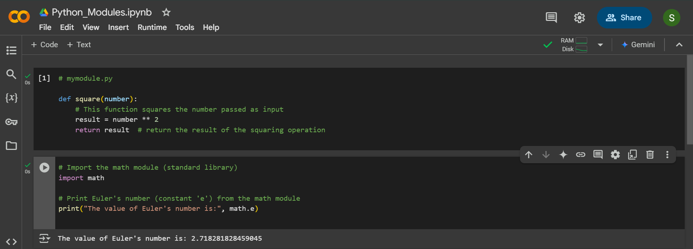

**Importing and also Renaming**

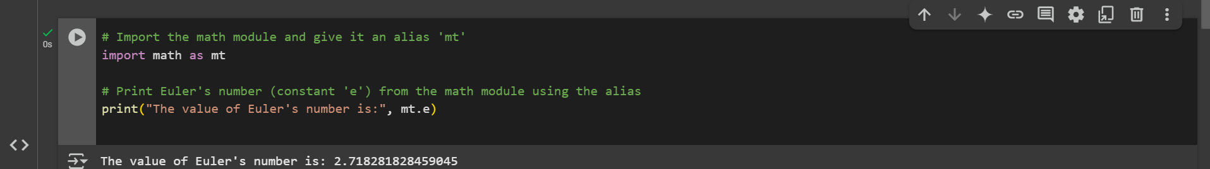

**Python from...import Statement**

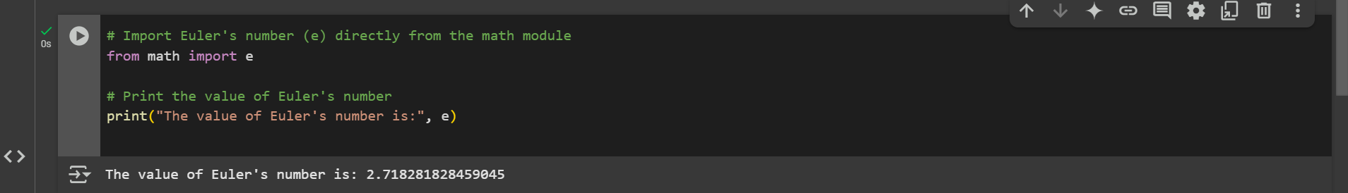

**Import all Names - From import * Statement**

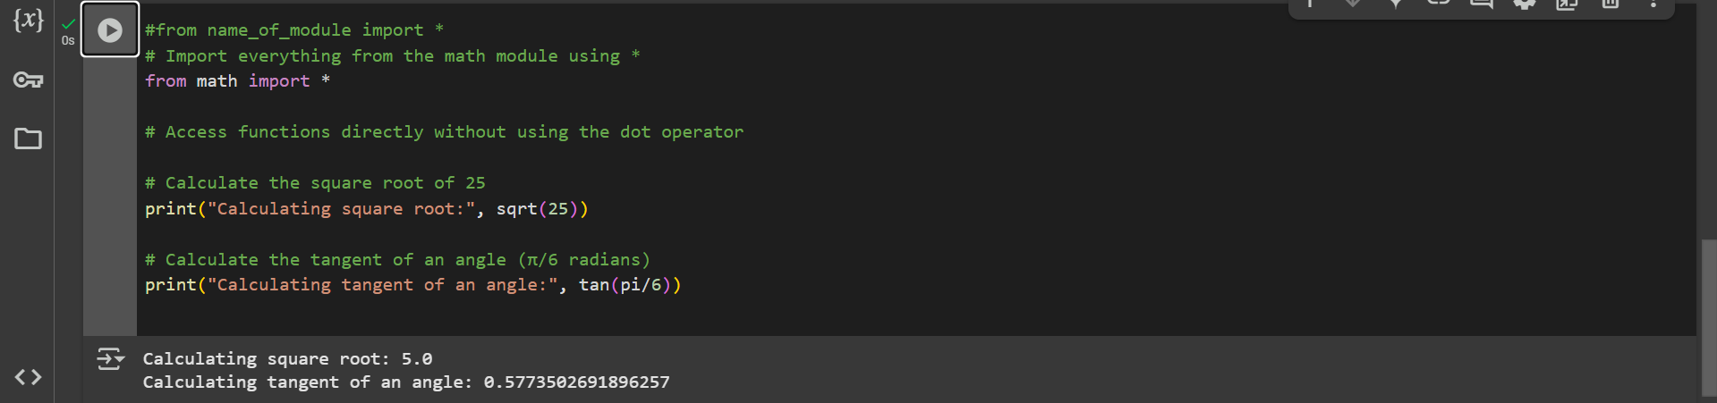

**Locating Path of Modules**

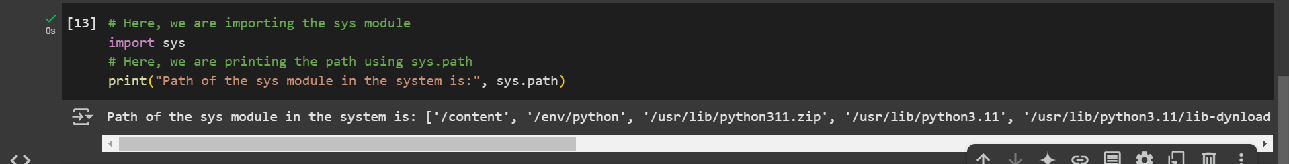

**The dir() Built-in Function**



**Namespaces and Scoping**

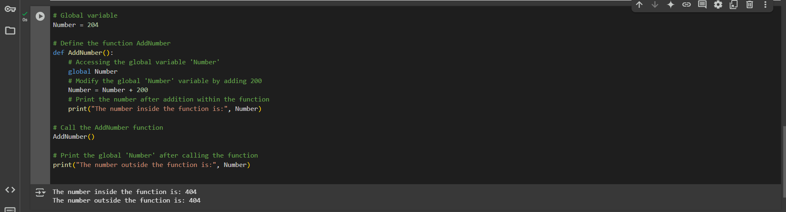

**Python Exceptions**

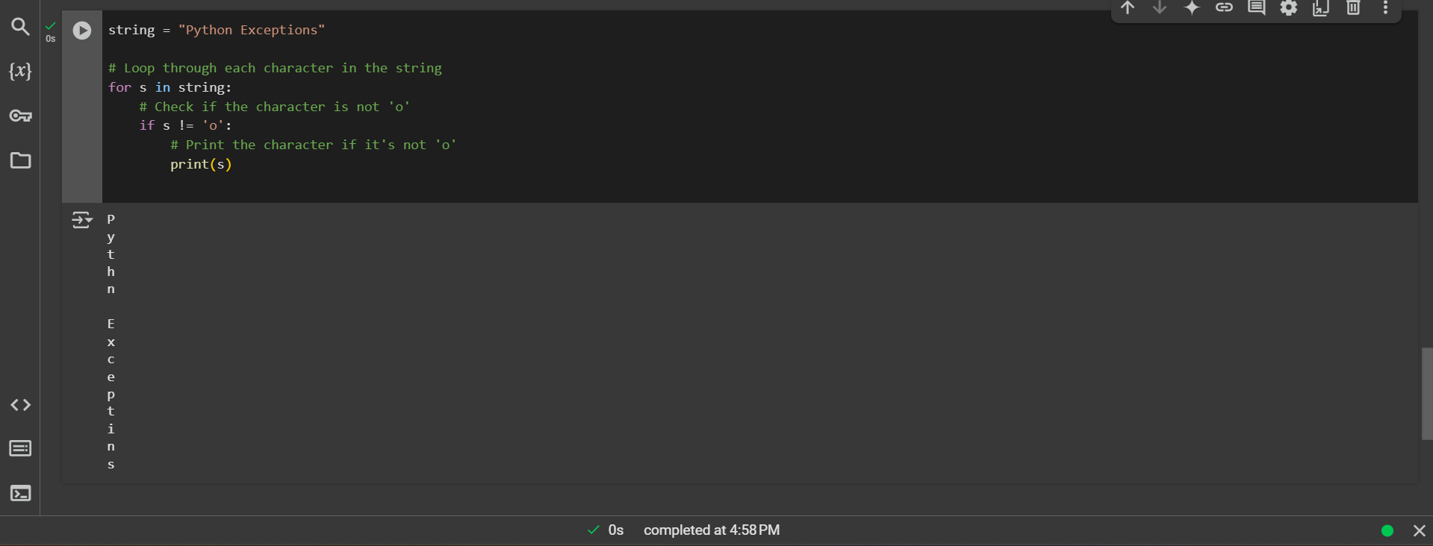

**Try and Except Statement - Catching Exceptions**

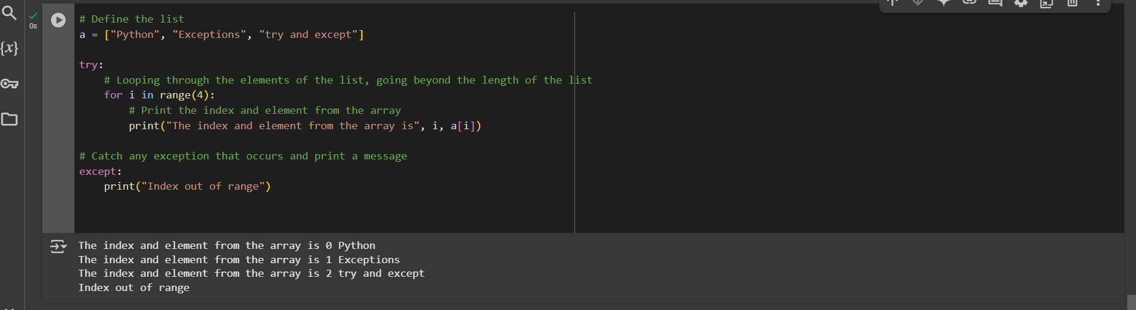

**How to Raise an Exception**

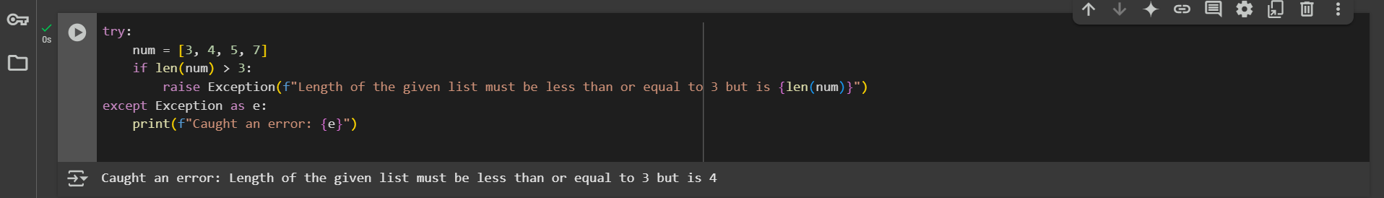

**Assertions in Python**

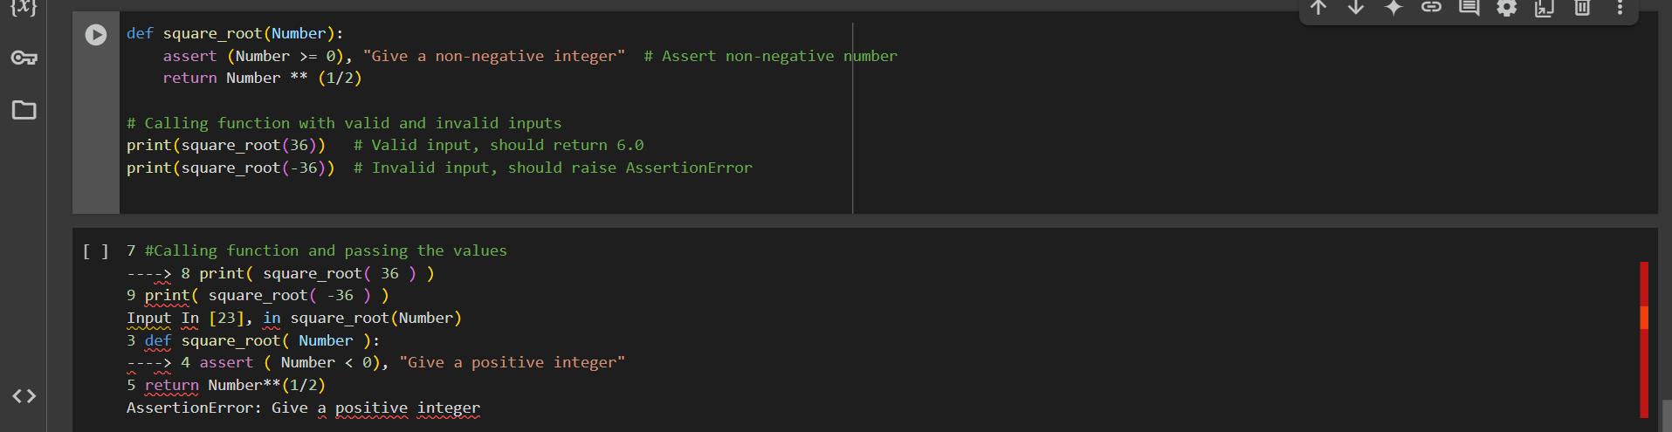

**Try with Else Clause**

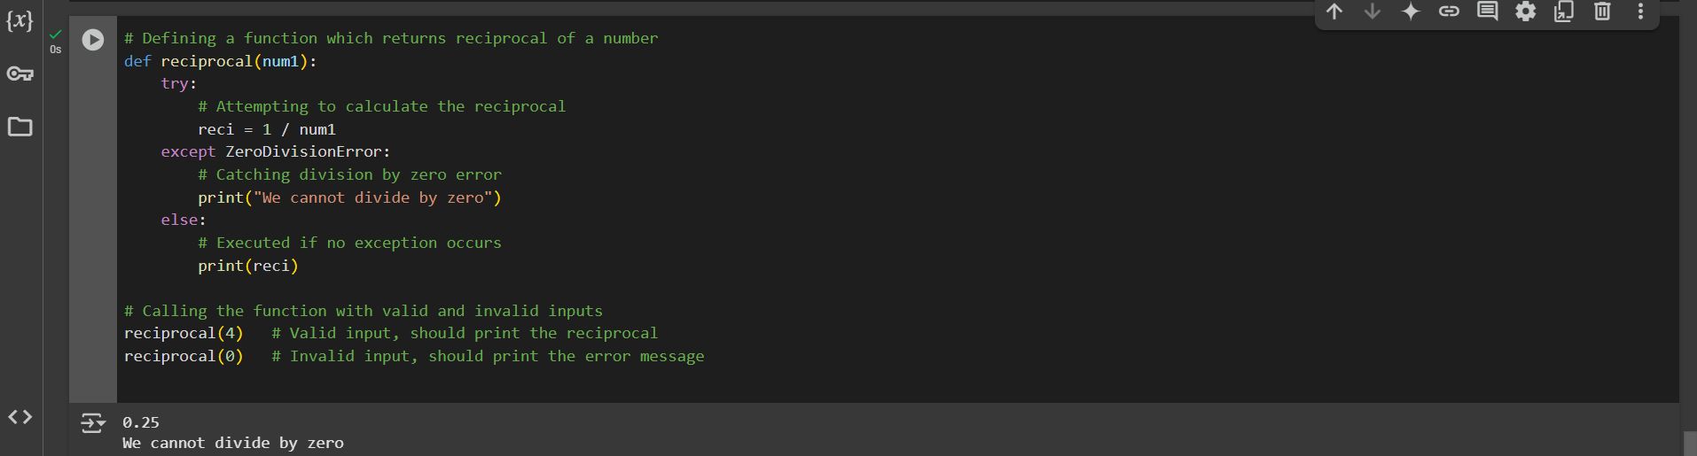

**Finally Keyword in Python**

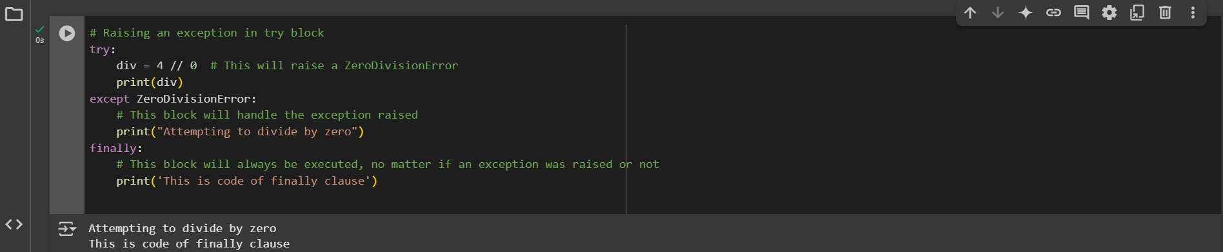

**User-Defined Exceptions**

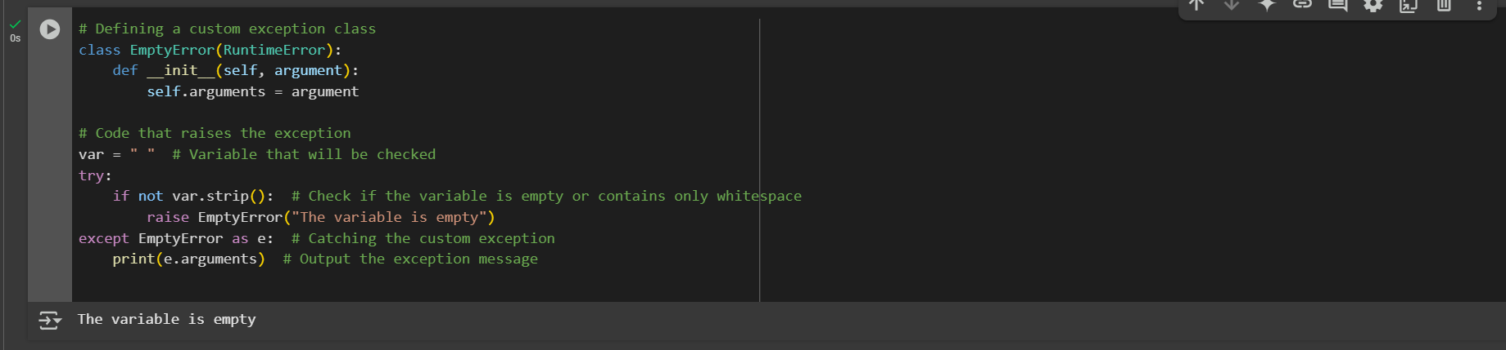

**try, except, else, and finally clauses**

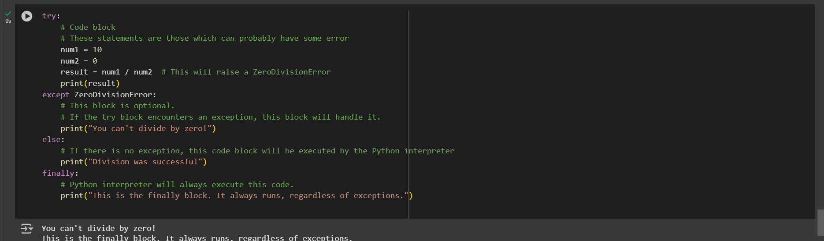

**Python Arrays**

**Accessing array element**

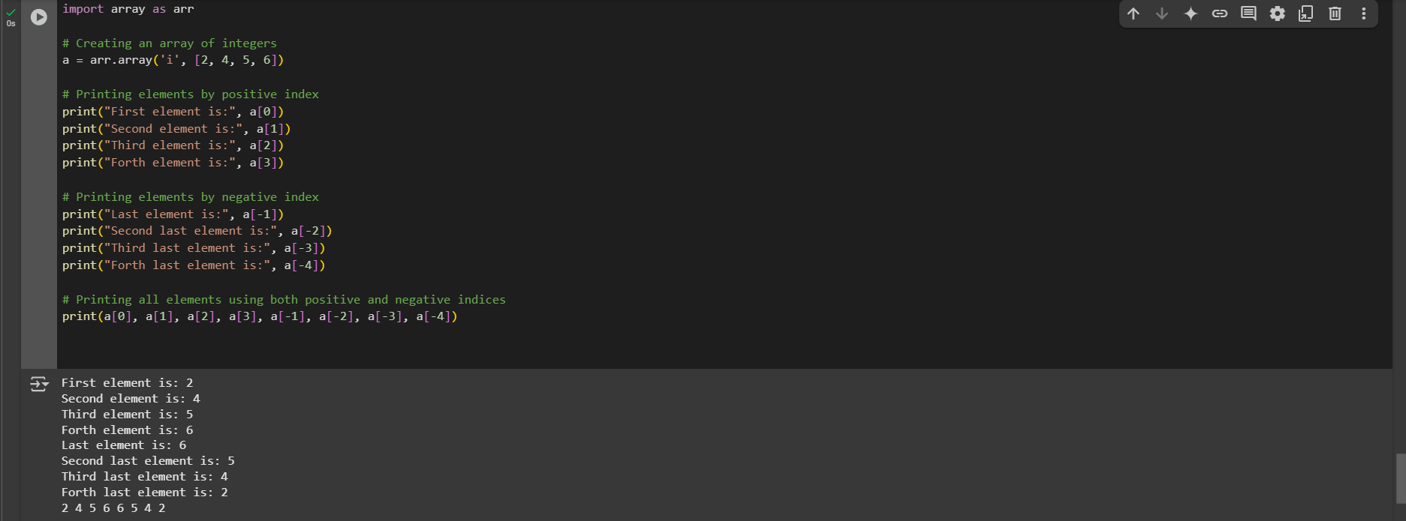

**Arrays are mutable, and their elements can be changed similarly to lists.**

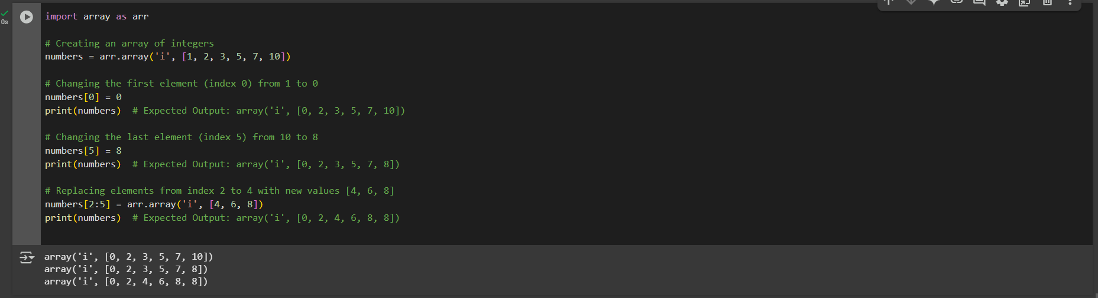

The elements can be deleted from an array using Python's del statement. If we want to delete any value from the Array, we can use the indices of a particular element.

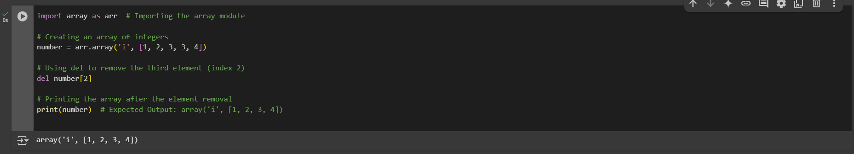

**Array Concatenation**

We can easily concatenate any two arrays using the + symbol.

Example 1:

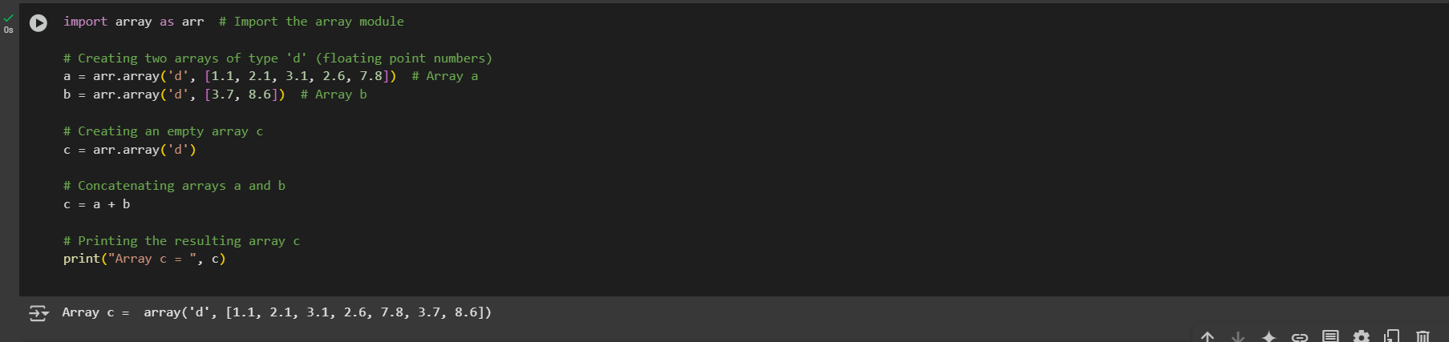

**Example 2:**

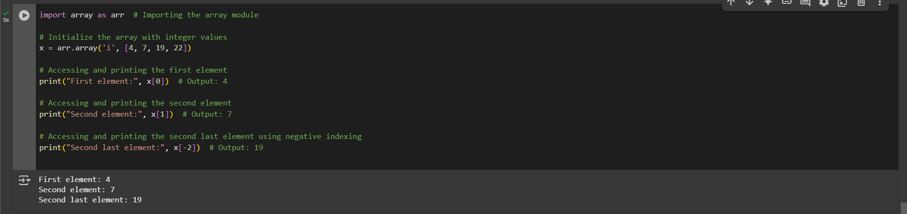

**Python Decorator**

**Example**

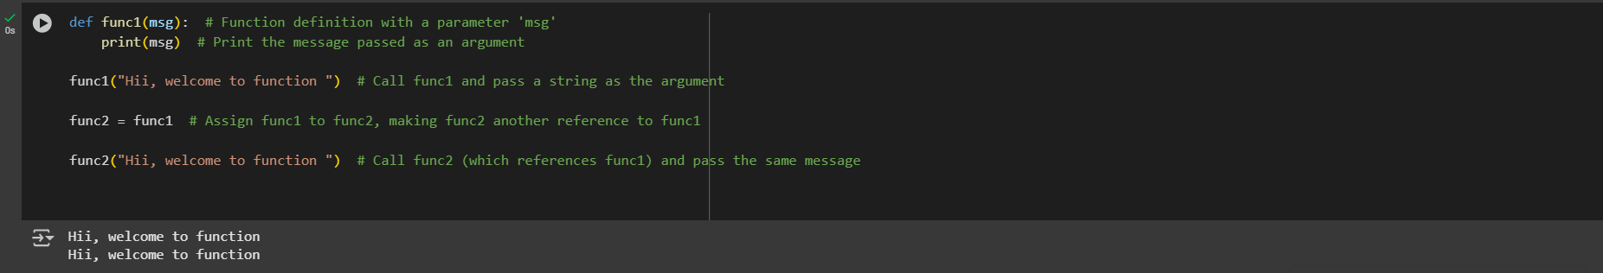

**Inner Function**

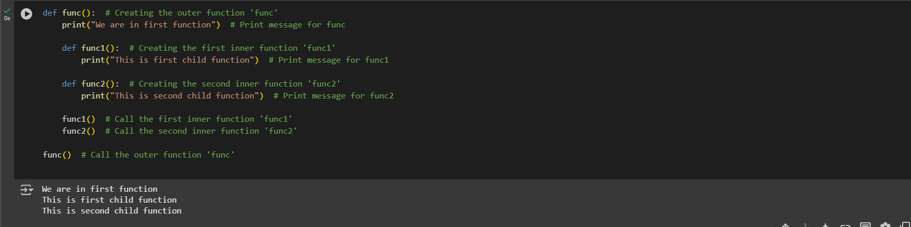

A function that accepts other function as an argument is also called higher order function. Consider the following example:

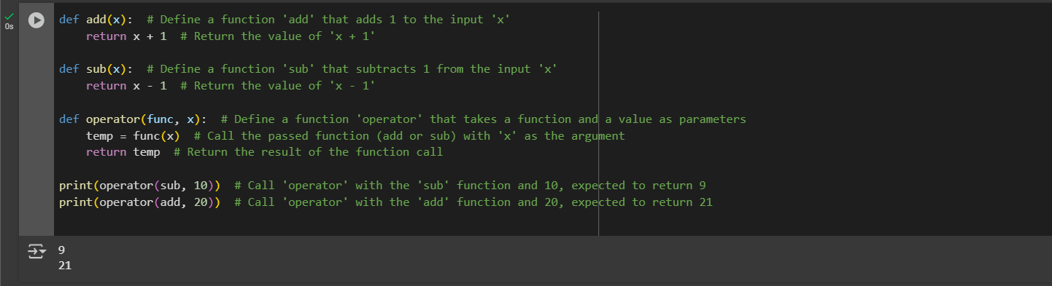

**A function can return another function. Consider the below example:**

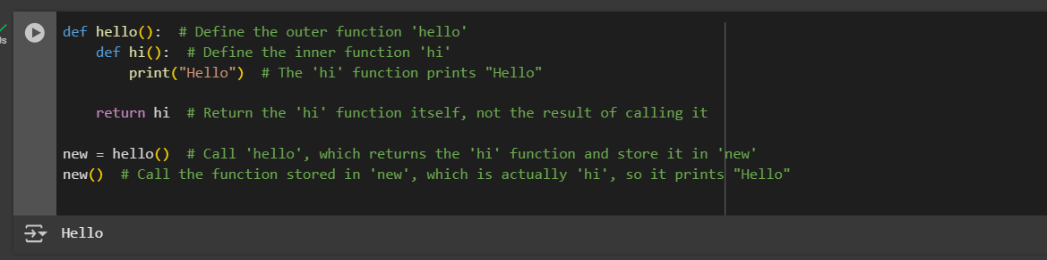

**Decorating functions with parameters**

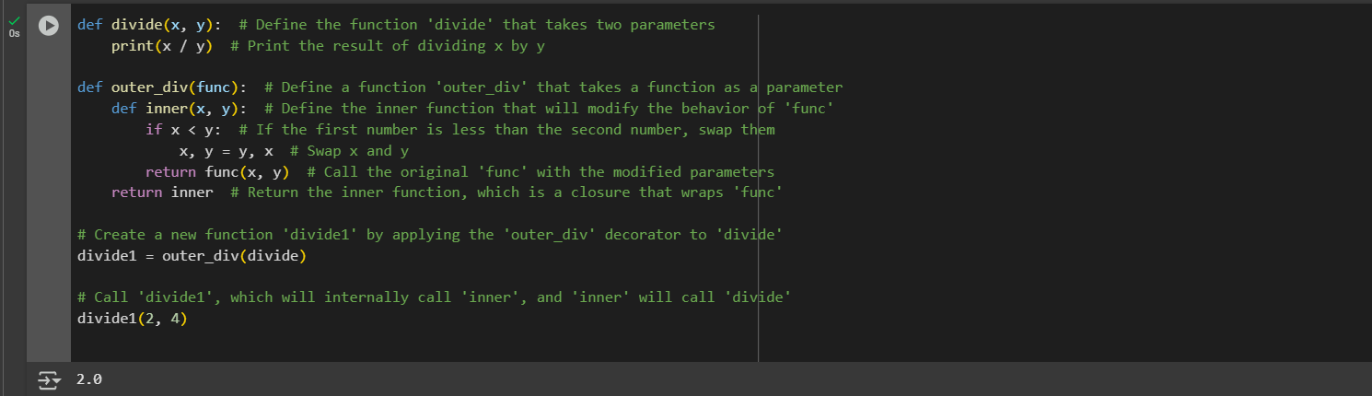

**Syntactic Decorator**

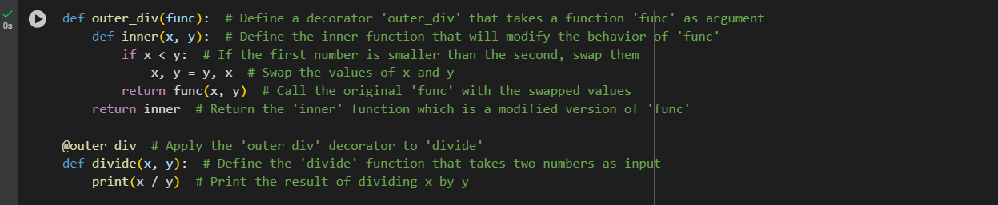

**Reusing Decorator**

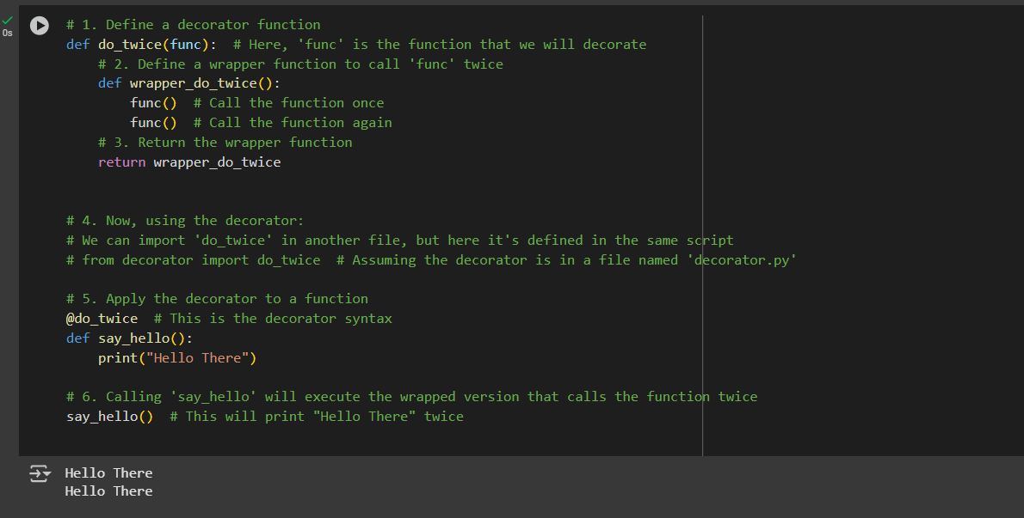

**Fancy Decorators**

**Example: 1-** @property decorator - By using it, we can use the class function as an attribute. Consider the following code:

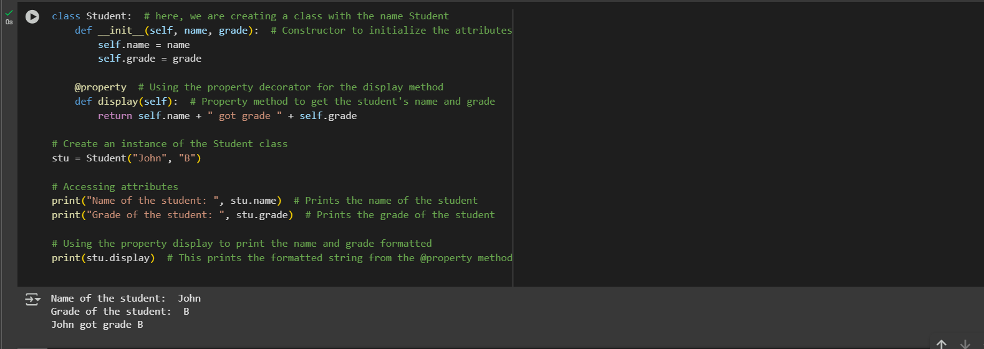

**Example: 2-**

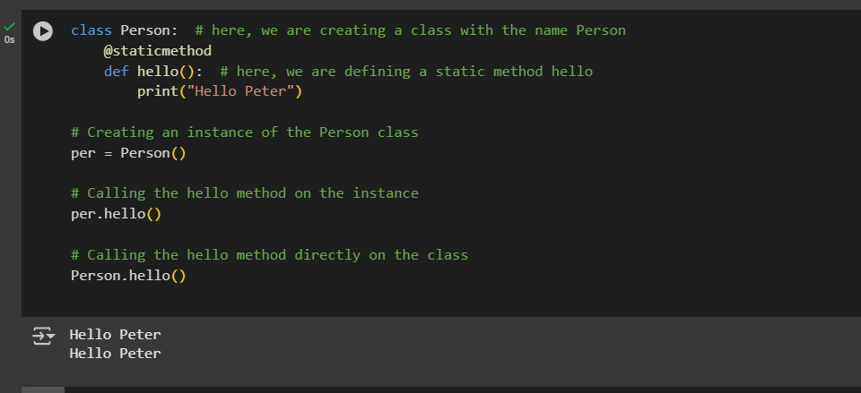

**Decorator with Arguments**

It is always useful to pass arguments in a decorator. The decorator can be executed several times according to the given value of the argument. Let us consider the following example:

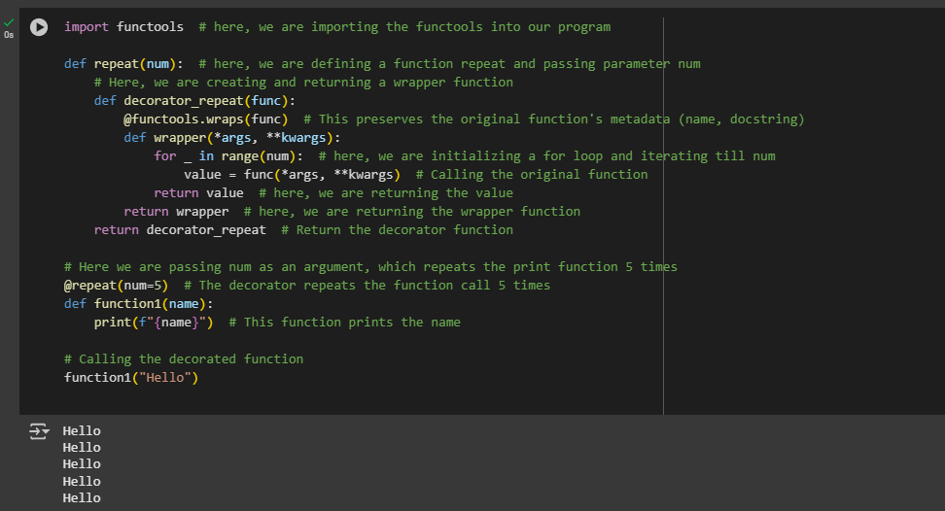

**Stateful Decorators**

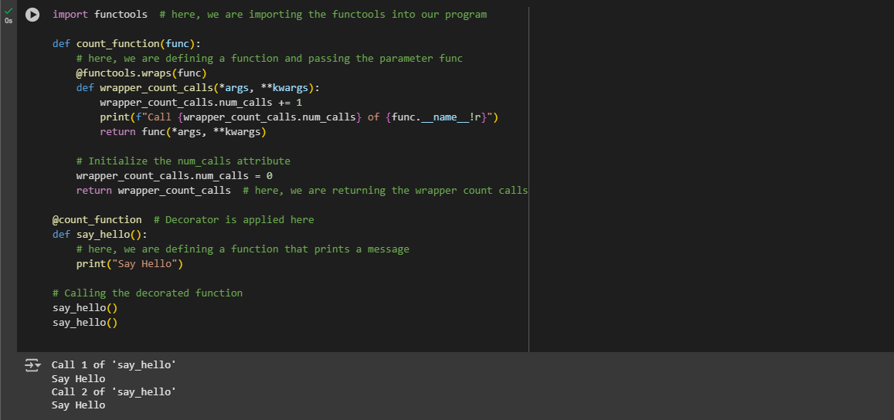

**Classes as Decorators**

